**Midterm Study Guide**

1. Make observations and inferences from the picture below

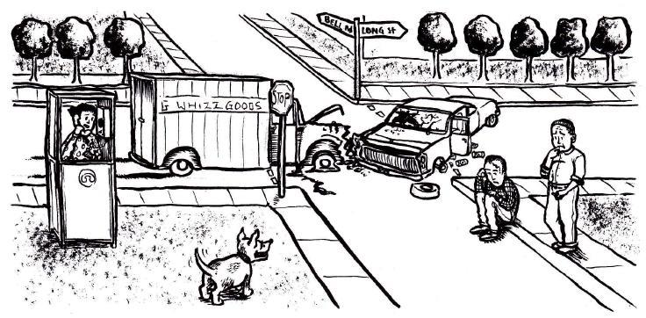

2. Review Newton’s Laws and be able to identify examples of each

**Solve the following problems**

3. What is the acceleration of a 5000 g object pushed with a force of 10 newtons?

4. How much time does it take for a bird flying at a speed of 60 kilometers per hour to travel a distance of 360,000 meters?

5. If an object has mass of 2,000 grams moving at 9 m/s, determine its K.E.

6. Explain data from a chart

7. Be able to determine net force and direction

8. Explain the following diagram

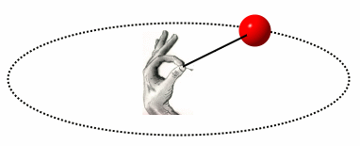

9.What factors affect the strength of an electromagnet?

10. Know claim and evidence for the car/elephant CER