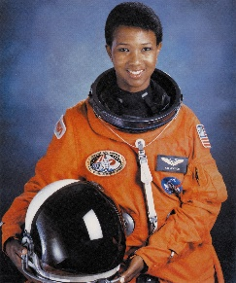

**Let’s celebrate African American SCIENTISTS!**

[**http://www.moptopshop.com/mop_top_scientist.html**](http://www.moptopshop.com/mop_top_scientist.html)

**Choose a scientist:** You will be researching to create a PowerPoint or about an African Americans in the science world.

**Some scientist you could research are:**

1. Ben Carson
2. Bessie Coleman
3. Charles Drew
4. Marc Hannah
5. Mae Jemison

**Your research should include but is not limited to**

* The scientist’s full name and personal facts about them (When and where they were born etc.)
* Their contribution to science.
* Educational background.
* 2-3 Interesting facts about him/her.

You will be **graded** upon your accuracy/correctness for a possible total of **ten (10) summative points.**