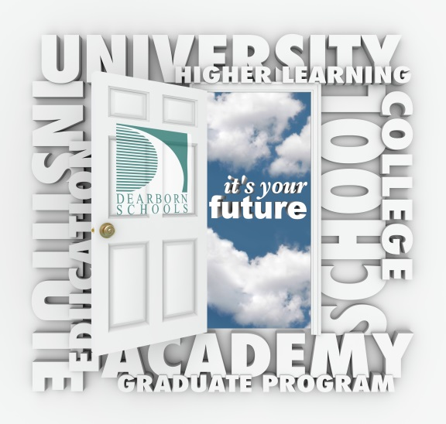

**Dearborn Public Schools**

**is pleased to host the**

**Dearborn Schools**

**MACRAO College Fair**

**September 20, 2016 6:30pm-8:00pm**

**Ford Community and Performing Arts Center**

**15801 Michigan Avenue, Dearborn 48126**

Representatives from more than 60 different post-secondary schools will be available to talk with students. This event is open to all Dearborn schools and surrounding districts!

Just a few of the participating educational institutions include:

Central Michigan College for Creative Studies

Eastern Michigan Grand Valley State

Henry Ford College Kettering University

Lawrence Tech. Michigan State

Northern Michigan Oakland University

Saginaw Valley University of Detroit Mercy

University of Michigan University of Windsor

Harvard University of Illinois- Chicago

Columbia College- Chicago Savanna College of Art & Design

Syracuse University Gannon University

Plus many other

* Universities
* Trade Schools
* Law Enforcement Agencies
* Colleges
* U.S. Armed Forces

**For more Information e-mail:Welmerg@dearbornschools.org**