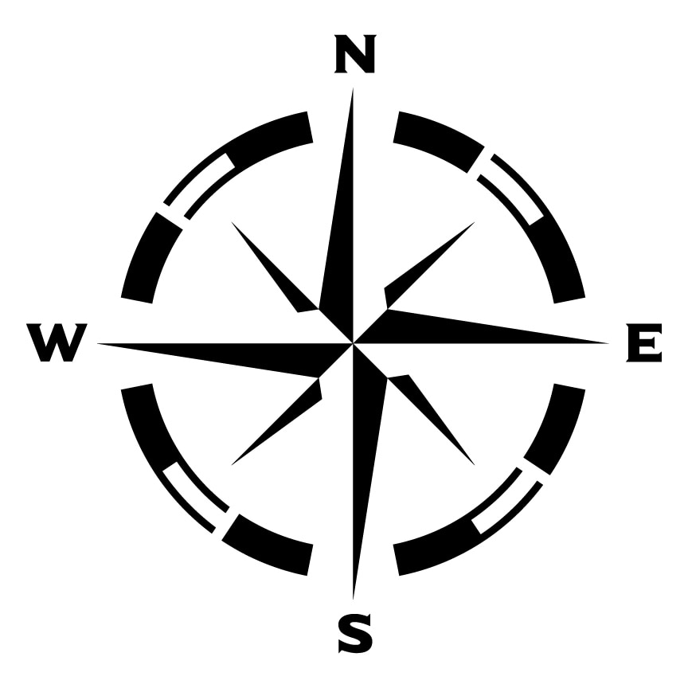**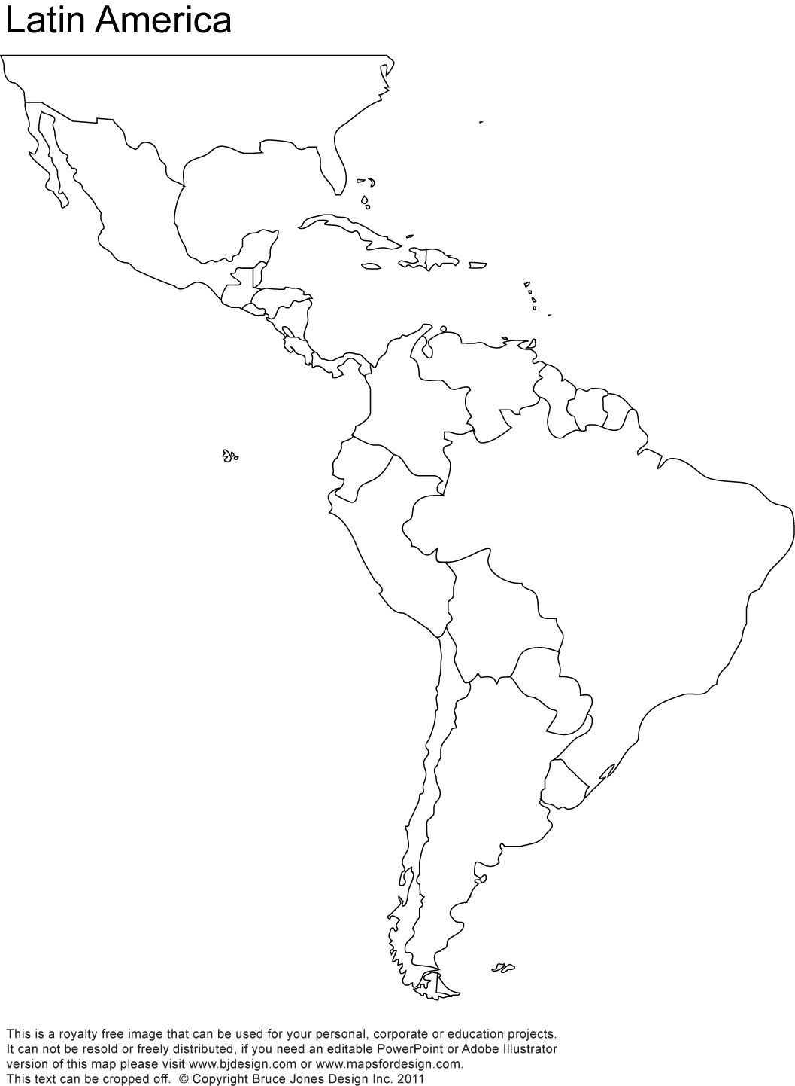Directions**: label the countries in Latin America. Then make a colored key to identify the European rule in Latin America.

* Atlantic Ocean
* Pacific Ocean
* Dutch Guiana
* French Guiana
* Viceroyalty of Brazil
* Viceroyalty of Peru
* Viceroyalty of Spain
* Santo Domingo
* Captaincy-General of Venezuela
* Viceroyalty of New Granada
* Br. Honduras
* Jamaica
* Saint-Domingue
* Santo Domingo
* Gulf of Mexico
* Caribbean Sea

British colonies

Dutch Colonies

French Colonies

Spanish Colonies

Portuguese Colonies

1800