**Overview of the American Revolution**

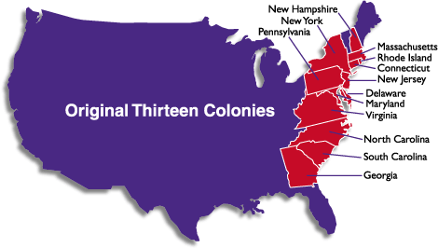The American Revolution was a time, between 1765 and 1783, when the British colonists living in the 13 colonies in America rebelled against the rule of Great Britain and King George III. King George, in order to pay for wars happening in Europe, began to place taxes on the colonists living in America. There were many battles fought by the British troops and the American Continental Army. The result in the 13 colonies was the colonists gained their freedom and independence from Great Britain. King George no longer ruled over the people of the colonies. The American Revolutionary War lasted from 1775 until 1783.

**Q:**

When did the revolution happen? متى حدثت الثورة؟

Where did the revolution take place? أين حدثت الثورة؟

Name ONE of the original 13 colonies. اسم واحد من 13 مستعمرات.

Who was the revolution fought between? من كانت الثورة التي خاضتها؟

Why did the revolution happen? لماذا حدثت الثورة؟

**A:**

The revolution happened ___________________________________.

The revolution took place in ______________________________________.

One of the original 13 colonies is ________________________________________.

The revolution was fought between __________________________.

The revolution happened because ____________________________.