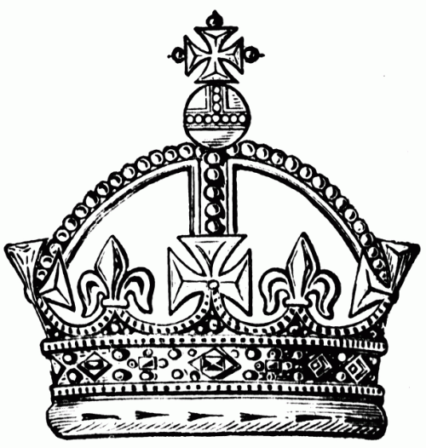**Age of Absolute Monarchy in Europe**

An Absolute Monarchy is when a country is ruled by one person. A monarch is usually a king or a queen. Their actions are restricted neither by written law nor by custom. A monarchy becomes a leader by family. It is passed down as family inheritance. An absolute monarch’s main benefit is that their power is unlimited and inherited, they are the supreme leader. The absolute monarchy was established in the 16th century in Europe. They held unlimited power and everyone living in their territory owed them allegiance. The absolute ruler controlled the government and expanded the armies to keep the country safe.

Absolute monarchs and their citizens believed that god sent down a message for one person to rule. This is known as the divine right. All European monarchs believed they had a divine right to be king or queen. They used this power to keep people in control. This also meant that they had complete control of a country’s religion. The king or queen is the only one who can hold all the power and make all the decisions. The citizens did not have freedom and no rights to vote or be a part of law making or elections. An absolute monarchy is organized by nothing. It has no rules, no constitution or legally organized opposition.

Absolute monarchs were the top of the social class. They showed off their power to the lower class of people. They also used this power to encourage trade with other countries so that they can increase income and wealth. This allowed them to control and tax their people as they wished. A monarch had no tolerance for people who did not pay their taxes and set punishments for those who did not.

Absolute rulers also dominated cultural life. They set rules for the country as far as art, literature, music and dance. They wore the finest clothes and set the example for how people in the country should dress, even though they could not afford it.

One of the most famous monarchs was King Philip II of Spain. He led the Spaniards to conquer Portugal but failed when he tried to take over England. You will learn more about Philip in the next section.