Shark Tank Project Name: _________________________________ Hour: _______
DUE: Friday December 20, 2019

Task
You will be creating a business plan & visual presentation of a unique product or service as if you were presenting this idea to the sharks on shark tank. As you create your project, think about the episodes of Shark Tank we’ve watched in class. What products did the sharks invest in? Why? What products did the sharks reject?

Procedures and Requirements
- Create a unique product idea that is a solution to a problem facing people/business/etc.
- Develop a business plan which includes all of the following sections: (A template will be provided on iblog, USE IT!!!)
  - Cover Page
  - Table of Contents
  - Business Description
  - Mission Statement
  - Market Analysis
  - Sales and Marketing
  - Management
- Come up with a creative way to pitch your idea to the sharks (think of the times we’ve watched shark tank)
  - This can be a google slide
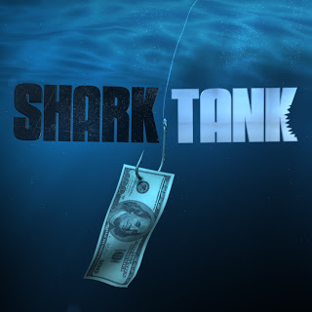
  - A small poster board
  - An example of your product
  - Something you can SHOW during your presentation

Grading

- Product (30 points)
  - Unique and creative
  - Sellable – Would people buy it?
- Business plan (50 points)
  - All sections are included and visibly labeled
  - Use of complete sentences, indented paragraphs and no spelling mistakes
  - Use of 12-point font and double spaced
  - Each section is clearly identified with its specific information
- Presentation to the Shark (Ms. Saghir) (20 points)
  - A visual is of the product/service is presented with your company name, slogan and logo
  - introduced yourself
  - introduced your business
  - introduced the product/service
  - identified the parts of the business plan
  - You made your product sellable that means you convinced the shark to invest in you!

You May Start here by answering these questions to get you started…
- What product/service will you be presenting?
- Is this product/service a new invention or an improvement on a previous one?
- How will this product/service solve a problem consumers are facing?
- Who is your target audience? Who are you trying to sell this to?
- What will your company name be called?
- What will your logo be?
- What will your slogan be?

