الإسم: __________________

الـتـاريـخ: _______________

الـحــصـة:_______________

Arabic 1, Semester 1, Final test study guide

1 Write the short sounds of letter د (2 points)

__________________________________________

2 Write the long sounds of letter د (1.5 points)

__________________________________________

3 Write the short sounds of letter ر (2 points)

__________________________________________

4 Write the long sounds of letter ر (1.5 points)

__________________________________________

5 Write the long sounds of letter ت (1.5 points)

__________________________________________

6 Fill in the blank with the correct shape of letter ت (2 points)

ـــــــــ ــاج بـ ــــــــــ ـر توـــــــــ ثــبــ ـــــــ

7 Write the long sounds of letter ي **_________________________ (1.5 points)**

8 Fill in the blank with the correct shape of letter ي (2 points)

شاـــــــــ ــــــــــ ـــد تــ ـــــــــــــــ ــن ثا نــ ـــــــــــ

9 Fill in the blank with the correct shape of letter ك (2 points)

ــــــــ ـتاب سـ ــــــــــ ـت شار ـــــــــ ديــ ــــــــ

10 Fill in the blank with the correct shape of letter ط (2 points)

ــــــــ ــارَ عـ ــــــــــ ـس خا ـــــــــ شريـ ـــــــــ

11 Fill in the blank with the correct shape of letter ج ( 2 points)

ــــــــ ـنـاح نــتــ ــــــــــ تا ـــــــــ حـ ــــــــــ ـر

12 Fill in the blank with the correct shape of letter ه ( 2 points)

ــــــــ ـرم وجــ ــــــــــ تا ـــــــــ نـ ــــــــــ ـر

13 Make a double bubble to compare and contrast letters غ ع (2 similarities and 2 differences) 5 points

14 Write the name of the following pictures: (6 points)

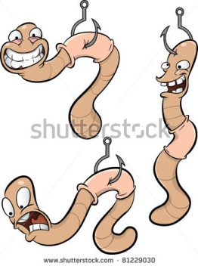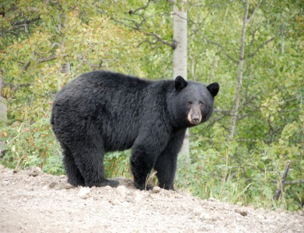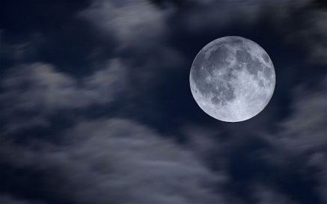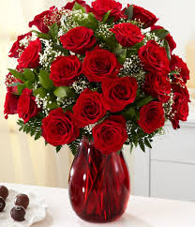

___________ _________________ __________________ _______________

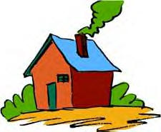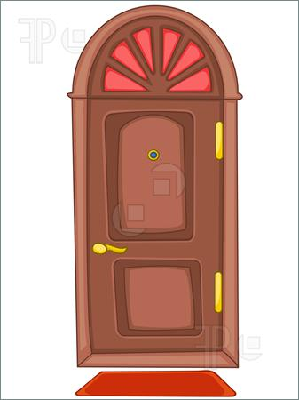

_______________________ __________________

15 Translate (8 points)

بُــرْتُــقــالي __________

أصْــفَــر __________

بُــنــي _____________

أخْــضَــر ____________

أبْــيَــض _____________

أزْرَق _____________

أحْــمَــر _____________

أسْــوَد _______________

16 Connect the following letters to form words: (8 points)

ج + ن + ا + ح = _____________

ن + ج + ر = ________________

ج + ب + ي + ن = _____________

ب + ا + ب = _______________

ت + ي + ن = ________________

ن + ا + ي = _______________

ه + ر + ب = _______________

و + ز + ن = _______________

ف + ه + د = ________________

17 Draw a person and label its body parts: (7 points)

عَــيْــن – أُذُن – بـَـطْــن – يَــد – رأْس- أنْــف – فَــم- ذِراع – قَــدَم- إصْــبَــع – رِجْــل – خــد- شــعْــر- رقــبــة

18 Rearrange the following words to make meaningful sentences: (3 points)

إسْــمــي – هادي – أنا

لُــبْــنــان- أنــا – مِــن

قَــلــم – هــذا – أحْــمَــر