Name: __________________________________________ Date: ________________ Hour:________

**Biology Study Guide Semester 2**

**Genetics**

1. **Identify** and **describe** homologous chromosomes with **homozygous** or **heterozygous** alleles.

* The cell has two sets of each **chromosome**; one of the pair is derived from the mother and the other from the father.
* An organism can be **homozygous** dominant, if it carries two copies of the same dominant **allele**, or **homozygous** recessive, if it carries two copies of the same recessive **allele**.
* **Heterozygous** means that an organism has two different **alleles** of a gene.

1. **Draw** and **label** homologous chromosomes with **homozygous** or **heterozygous** alleles.

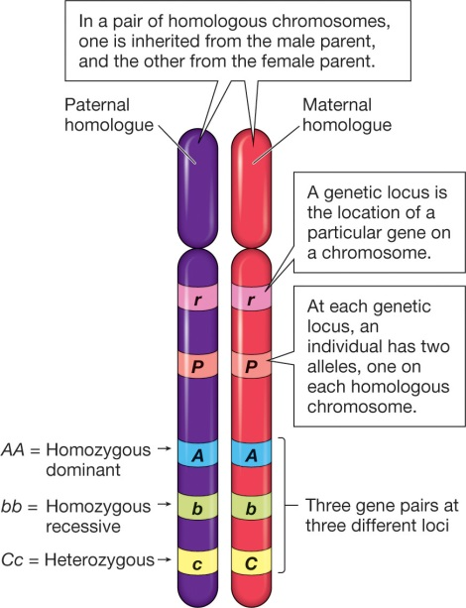

1. Describe the difference between **dominant** and **recessive** alleles.

* For a **recessive allele** to produce a **recessive** phenotype, the individual must have two copies, one from each parent. An individual with one **dominant** and one **recessive allele** for a gene will have the **dominant** phenotype.

1. State the difference between a **genotype** and a **phenotype**.

* The **genotype** is the set of genes in our DNA which is responsible for a particular trait.
* The **phenotype** is the physical expression, or characteristics, of that trait.

1. Use a Punnett Square to **predict** all of the possible genotypes and phenotypes of the offspring when crossing two parents with a specific trait.

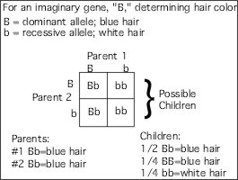

1. Describe the different inheritance patterns for:

Complete Dominance- the effect of one allele in a heterozygous genotype completely masks the effect of the other.

Incomplete dominance- one allele for a specific trait is not completely expressed over its paired allele. This results in a third phenotype in which the expressed physical trait is a combination of the phenotypes of both alleles.

Codominance- the alleles of a gene pair in a heterozygote are fully expressed

Sex – Linked- tending to be associated with one sex (male or female) or the other

1. Identify traits that are polygenic.- skin color, eye color, height
2. Use a pedigree to determine the inheritance pattern.

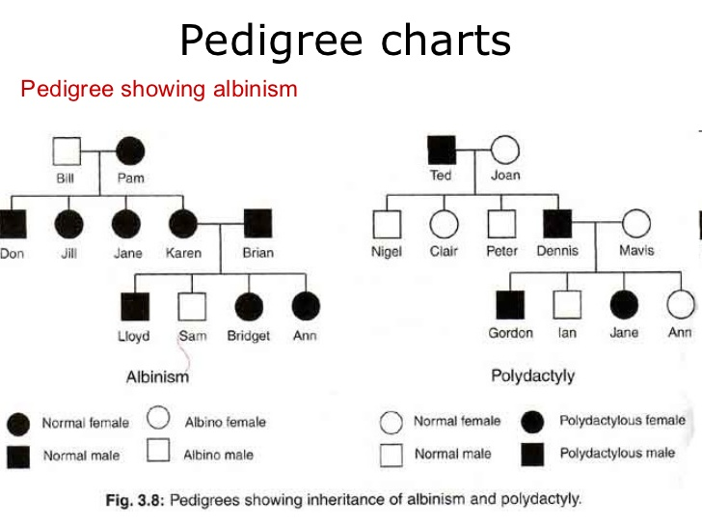

1. Describe how a mutation in a gamete will be passed on to the offspring.

The only mutations that matter to large-scale evolution are those that can be passed on to offspring. These occur in reproductive cells like eggs and sperm and are called germ line mutations.

1. Describe how a mutation in a body cell has a different result than a mutation in a sex cell.

Mutations in somatic cells are called somatic mutations. Because they do not occur in cells that give rise to gametes, the mutation is not passed along to the next generation by sexual means.

**DNA**

1. Describe the structure and function of DNA. (include the types of bonds)

* Each nucleotide contains a phosphate group, a sugar group and a nitrogen base. The four types of nitrogen bases are adenine (A), thymine (T), guanine (G) and cytosine (C).
* Hydrogen bonds between G-C and A-T base pairs

1. Describe the structure and function of RNA.

* Single stranded and contains ribose as its pentose sugar and uracil instead of thymine
* It plays a role in protein synthesis

1. Explain the complementary base pair rules.

* A with T: the adenine (A) always pairs with the thymine (T)
* C with G: the cytosine (C) always pairs with the guanine (G)

1. Predict the consequences that changes in DNA may have on an organism.

* Change the function of DNA, Mutations, and cancer

1. Demonstrate how the genetic information in DNA molecules provides instructions for assembling protein molecules.
2. Describe the processes of transcription and translation in making proteins.

* DNA makes RNA, RNA makes proteins.
* The process by which DNA is copied to RNA is called transcription, and that by which RNA is used to produce proteins is called translation.

1. Read/use the Amino Acid chart to decode codons.

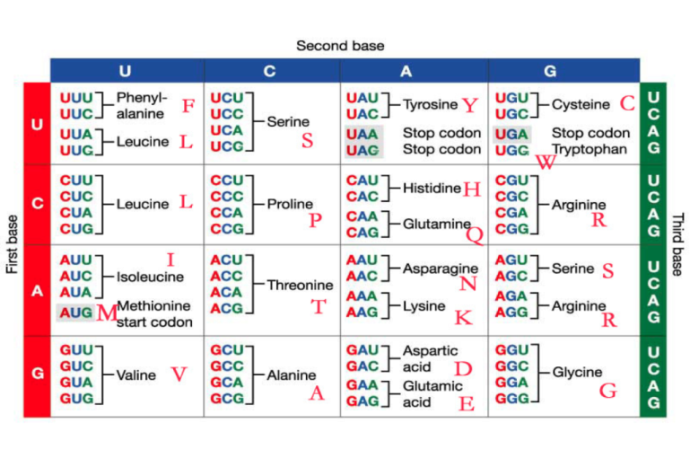

1. Use a karyotype to identify possible genetic defects in an offspring.

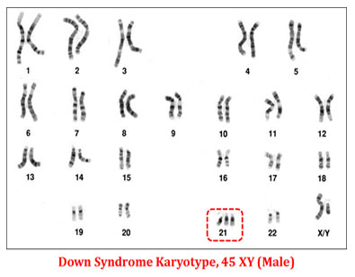

**Cell Division**

1. Compare and contrast mitosis and meiosis and describe key differences between them.

* Meiosis has two rounds of genetic separation and cellular division while mitosis only has one of each.
* In meiosis homologous chromosomes separate leading to daughter cells that are not genetically identical.
* In mitosis the daughter cells are identical to the parent as well as to each other.

1. Compare and contrast sexual and asexual reproduction and state advantages and disadvantages of each.

* Sexual reproduction just means combining genetic material from two parents.
* Asexual reproduction produces offspring genetically identical to the one parent.
* https://quizlet.com/_xcqzk

1. Explain why offspring resemble their siblings and parents.

* So children look like combinations of their parents because they are. Each parent gives half of their genetic material to their children. The combination makes a unique combination of their parents’ genes.

1. List the phases of meiosis I and meiosis II and describe the events characteristic of each phase.

* Meiosis 1: -prophase 1: homologous chromosomes pair, exchange segments

-metaphase 1: tetrads line up

-anaphase 1: pairs of homologous chromosomes split

-telophase 1: haploid cells (2) form

Meiosis 2: sister chromatids separate, 4 haploid daughter cells formed

1. Identify the phases of meiosis I and meiosis II from diagrams or micrographs.

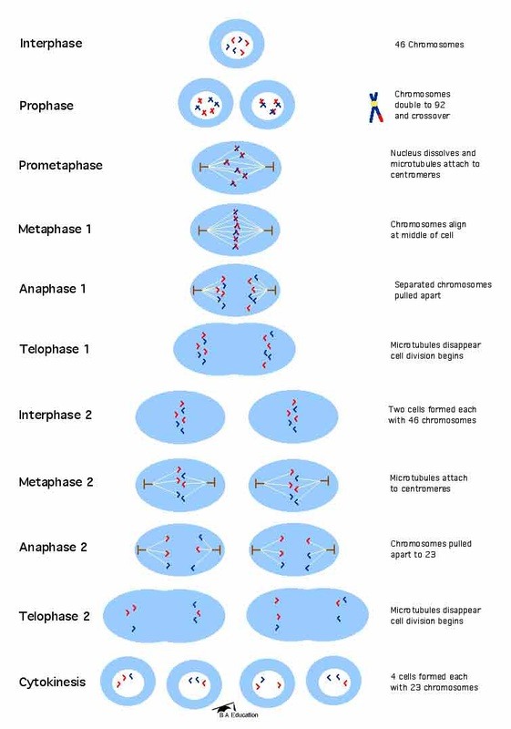

1. Explain how the end result of meiosis differs from mitosis.

* Meiosis ends with 4 genetically different cells (1n)
* Mitosis ends with 2 genetically identical cells (2n)

1. Define independent assortment and crossing over and what happens in each.

* Independent Assortment- different genes independently separate from one another when reproductive cells develop
* Crossing over occurs between prophase 1 and metaphase 1 and is the process where homologous chromosomes pair up with each other and exchange different segments of their genetic material to form recombinant chromosomes.

1. Explain why offspring are not identical to their siblings and parents due to crossing over, independent assortment and random fertilization.

* https://www.ck12.org/biology/Genetic-Variation/lesson/Genetic-Variation-Advanced-BIO-ADV/