PHYSICS SEMESTER 1-FINAL EXAM REVIEW
Unit 1  Introduction - About Science  Scientific Notation  Prefixes/conversions  Units and Measurements | Unit 2  Ch 2 – Mechanical Equilibrium  Ch 4 – Linear Motion  Ch 5 – Projectile Motion | Unit 3  Ch 3 – Newton’s 1st Law  Ch 6 – Newton’s 2nd Law  Ch 7 – Newton’s 3rd Law
Unit 4  Ch 8 – Momentum  Ch 9 – Work, Power, Energy | Unit 5  Ch 10 – Circular Motion  Ch 12 – Rotational Inertia  Ch 13 – Universal Gravitation | Finals:  1st/2nd – morning of 1/27  3rd/4th – morning of 1/28  5th/6th – morning of 1/29

Unit 1:

Chapter 1 - Scientific Method

List the steps of the scientific method.
- What is the difference between a fact and a hypothesis?
- What is the difference between a theory and a hypothesis?
Scientific Notation
- Understand the correct format for scientific notation.
- Be able to put numbers into, and take numbers out of scientific notation.
- Understand why we use scientific notation and what it does for us.
- Understand how to use scientific notation in a calculator.
Prefixes/Conversions
- Understand how to identify a prefix, what it does for us, and how to use it.
- Understand how prefixes are linked to decimal places and how to convert to/from a prefix.

Unit 2:

Chapter 2 - Mechanical Equilibrium
- Understand the ideas of vector quantities and scalar quantities. Know examples of each.
- Be familiar with vectors, resultant vectors, and basic vector addition.
- Know what forces are and understand what a net force is and how we figure it.
- What is the net force on a box that is being pulled right with 40 N and pulled left with 30 N?
- What is the maximum and minimum resultant possible from a 20-N force and 4-N force?
- What name is given to the stretching force that occurs in a rope being pulled?
- Understand the ideas of mechanical equilibrium, static equilibrium, and dynamic equilibrium.

Chapter 4 - Linear Motion
- Understand the ideas of speed and velocity and how they compare.
- Understand the ideas of velocity and acceleration and how they comare.
- Understand the idea of change in velocity, when we use it, and how to find it.
- It takes you 950 seconds to get to the mall which is 7000 meters away. What is your average speed?
- As you enter a highway you increase your speed from 50 mph to 70 mph in 5 seconds. What is your acceleration?
- How much time would it take a truck to reach 25 m/s from rest if it accelerated at 5 m/s²?
- Understand the ideas of free fall and acceleration due to gravity.
- Understand the ideas and equations for acceleration, velocity, and distance as an object falls.
- A rock falls from a cliff. It takes 2 seconds for it to hit bottom. How high is the cliff? How fast was the rock moving when it hit the ground?

Chapter 5 - Projectile Motion
- Understand what a projectile is.
- Understand the 2 components of a projectile and how they are related.
- At the very top of the trajectory, describe an object’s velocity and acceleration.
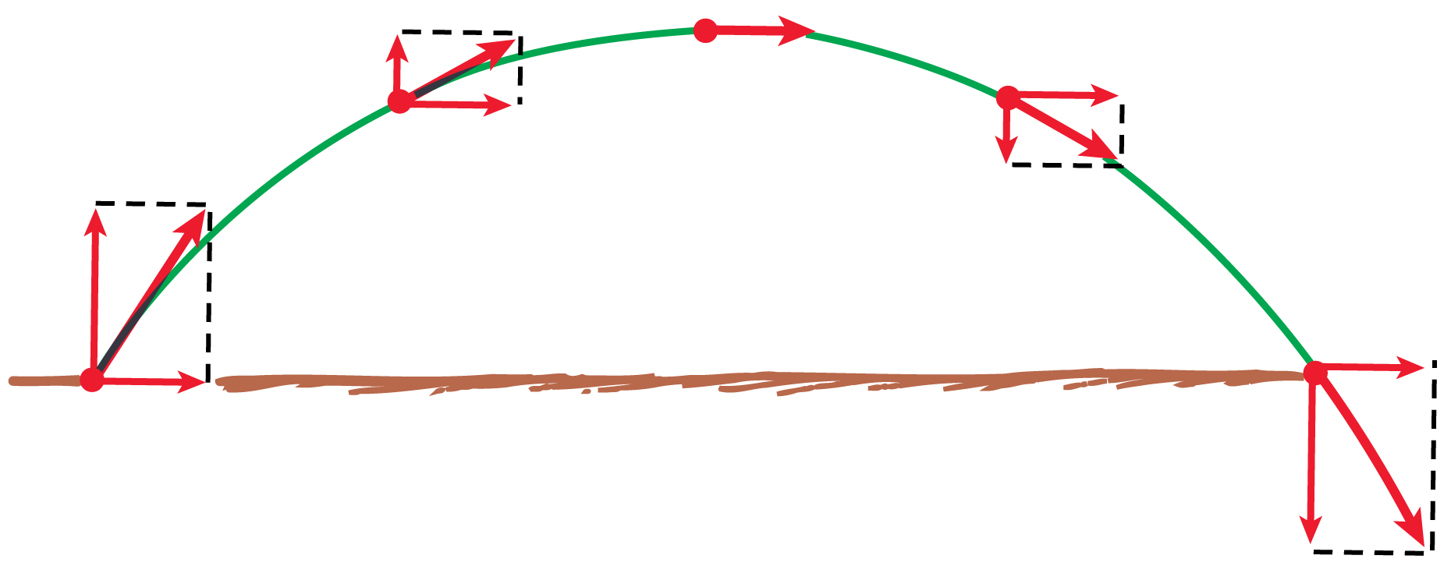
- Explain the figure below:
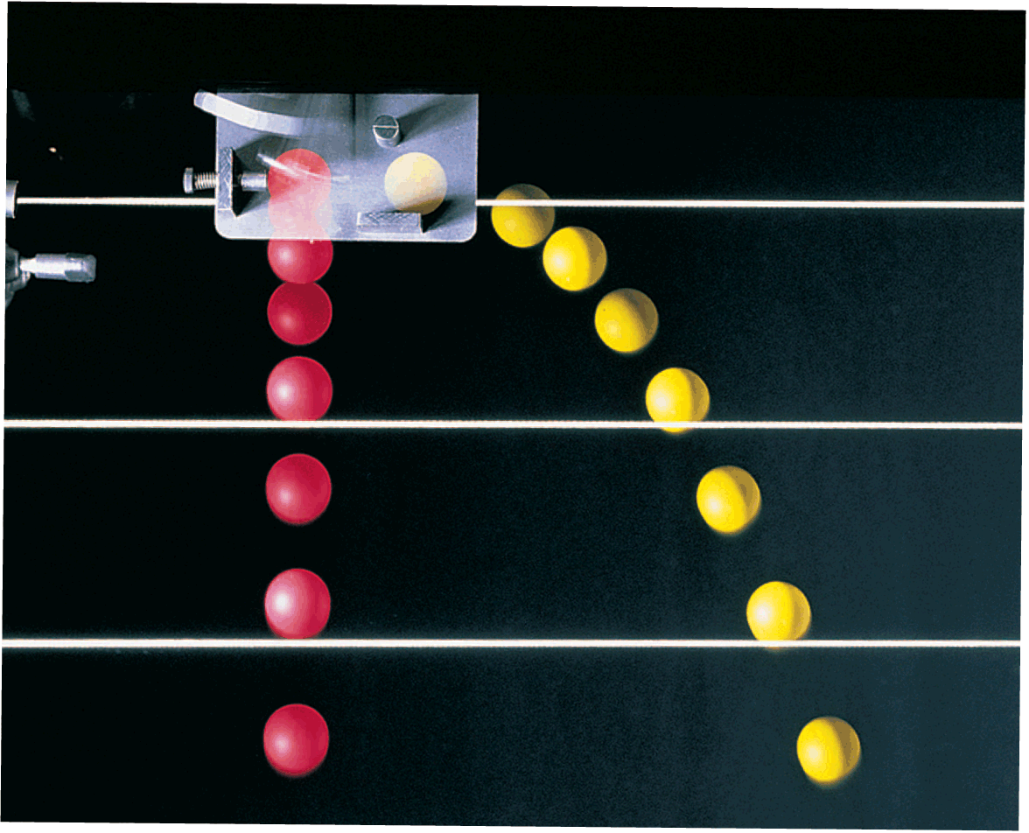

- Know what affect launch angle has on a projectile and which is most efficient.
- Understand how 2 launch angles can land in the same spot.

Unit 3:

Chapter 3 - Newton’s First Law of Motion
- Know Newton’s first law and what it is sometimes called.
- Understand the idea and details of inertia.
- Understand the definition, SI unit, and applications of force.
- Understand the definition, details, causes, and ideas of friction.
- Understand the definition, relationship, link, and SI units for mass and weight.
- What is the mass of a student who weighs 700 N?
- What is the weight in newtons of a student who has a mass of 60 kg?

Chapter 6 - Newton’s Second Law of Motion
- Understand the cause of acceleration, the relationship between mass and acceleration, and the relationship between force and acceleration.
- State Newton’s Second Law of Motion.
- You kick a 1 kg ball with 300 N of force. What is the acceleration of the ball?
- Understand the definition, formula, and SI unit for pressure.
- Understand the relationship between force and pressure, and area and pressure.
- Understand terminal velocity and its relationship to other characteristics of an object (mass, weight, net force, acceleration, air resistance, velocity)

Chapter 7 - Newton’s Third Law of Motion
- Understand Newton’s third law of motion.
- Understand what we mean by action/reaction forces and how they affect each other.
- If you hit a wall with a force of 200 N, how much force does the wall exert on you?
- Action: Ball hits bat with 1000 N. Reaction: ____________________.

Unit 4:

Chapter 8 – Momentum and Collisions
- For momentum, know the parts, relationships, formulas, SI units, definitions, and applications.
- For impulse, know the parts, relationships, formulas, SI units, definitions, and applications.
- Understand changing momentum, changing impulse, and the connection between them.
- Explain the 2 types of collisions.
- State the law of conservation of momentum and understand what parts are adjusted so others are conserved.
- What is the momentum of a 16 kg object moving at 8 m/s?

Chapter 9 - Work, Power, Energy
- Understand the definition, relationships, equation(s), and SI units for work.
- How much work is done by a crane that lowers 3000 N of material a distance of 200 meters?
- Understand the definition, relationships, equation(s), and SI units for power?
- How much power is needed to do 788 Joules of work in 160 seconds?
- A woman lifts a 350 newton child a distance of 1.5 meters in 0.75 seconds. What is her power output?
- Be familiar with the 2 types of mechanical energy, what they’re based on, their equations/calculations, SI units, and relationships to other measurements.
- Understand the law of conservation of energy, and how it affects transfer between types of energy and to other measurements.

Unit 5:

Chapter 10 - Circular Motion
- For rotation and revolution, be able to compare and contrast them, explain each, and give examples.
- A child is on a merry-go-round: which is rotating? Which is revolving?
- For linear (tangential) speed and rotational (angular) speed, be able to compare and contrast them, explain each, and give examples.
- For centripetal force and centrifugal force, be able to compare and contrast them, explain each, and give examples.
- When you whirl a can of water on a string, understand the – direction of the net force, direction of tangential speed, direction of acceleration of the can, the force keeping the water in the bottom of the can, and the direction the can flies if the string breaks.

Chapter 12 - Rotational Inertia
- Understand rotational inertia.
- Understand how changing the amount of mass, location of mass, shape of an object, or size of an object can have an effect on its movement.

Chapter 13 - Universal Law of Gravitation
- Understand what the universal law of gravitation explains, what it’s based on, and using the equation.
- Understand the relationship between force and mass, and force and distance.



