**Grade 2: Unit 6 Pre-Test**

**Which addends have a sum less than 150 feet?**  2.NBT.6/ 2.MD.5

1) 41 ft. + 22 ft. + 68 ft. Yes No

2) 23 ft. + 31 ft. + 37 ft. + 36 ft. Yes No

3) 75 ft. + 56 ft. + 24 ft. Yes No

4) **Nadia thinks that 14 + 22 + 26 + 14 is less than 12 + 30 + 24 + 18.**

**Is Nadia correct? Show your work to prove your answer.** 2.NBT.6

5) **Explain what strategy you would use to solve for 62 + 36 + 29.**

2.NBT.6

**_____________________________________________________________**

**_____________________________________________________________**

**_____________________________________________________________**

**_____________________________________________________________**

**My brother made 2 towers with his Lego’s. The height of one tower measured 28 cm. and the other measured 19 cm. How tall would the tower be if he added them together?** 2.MD.5

6)

Show your work.

Answer: _____________________

(units)

**A fence is 60 feet long. 35 feet have been painted. How many feet still need to be painted? (Show how you solved the problem on the number line.)** 2.MD.5

7)



________ feet of the fence still needs to be painted.

**Which statement(s) are true for the array below?**  2.OA.4

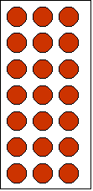

8) 4 + 4 + 4 + 4 Yes No

9) There are 2 rows. Yes No

10) There are a total of 8 dots. Yes No

11) **Write an addition sentence to show how many dots are in the box.**

2.OA.4

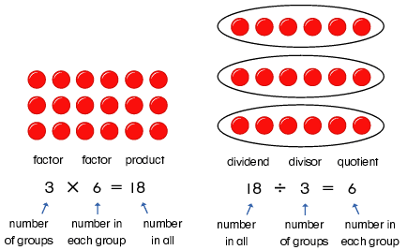

Addition sentence: ______________________________

There are _______ dots in the box.

12) **Jenna looked at the array and said, “3 + 3 = 6.”** 2.OA.4

**Devon looked at the array and said, “2 + 2 + 2 = 6.”**



**Who is correct? Explain your decision.**

___________________________________________________________________

___________________________________________________________________

___________________________________________________________________

**Use the graph below to answer the following questions.** 2.MD.10

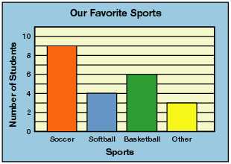

13) Basketball was chosen the most. . Yes No

14) 3 more students chose basketball then softball. Yes No

15) 9 people chose soccer. Yes No

**Favorite Ice Cream Flavor**

|  |  |  |  |
| --- | --- | --- | --- |
| **Vanilla** | **Chocolate** | **Moose**  **Track** | **Cookie**  **Dough** |
|  |  |  |  |

**16) Make a graph that shows how many children chose a favorite snack in each group.** 2.MD.10

**Favorite Ice Cream Flavor**



|  |  |  |  |
| --- | --- | --- | --- |
|  |  |  |  |
|  |  |  |  |
|  |  |  |  |
|  |  |  |  |
|  |  |  |  |
|  |  |  |  |
|  |  |  |  |
|  |  |  |  |
|  |  |  |  |
|  |  |  |  |
|  |  |  |  |



Number of Children



















**Vanilla Chocolate Moose Cookie**

**Track Dough**

17) Which flavor is most popular? ___________________________

18) How many children chose Cookie Dough? ___________________

19) How many more chose Chocolate over Moose Track? _________________