NAME: __________________________________

**GRADE 2: Unit 3 Pre-Test**

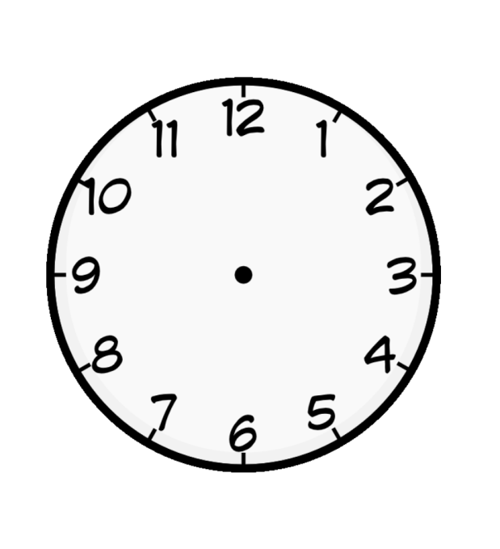What time does the clock read? 2.MD.7

1) 3:25 Yes No

2) 5:15 Yes No

3) 4:15 Yes No

4) Draw the hour and minute hands to show 3:20. 2.MD.7



5) Draw a minute hand on the clock. 2.MD.7

Tell what time the clock reads. ____________



Does the group of coins total 26 cents? 2.MD.8



6) Yes No



7) Yes No



8) Yes No

9) Using coins, show one way to make 47 cents. 2.MD.8

_________________________________________________________________

10) Dad cleaned out the car and found a quarter, three dimes, two nickels, and one penny.

Did he find more than a dollar? ___________ 2.MD.8

Prove it by using pictures, numbers, or words.

Write the number that the model shows. 2.NBT.2

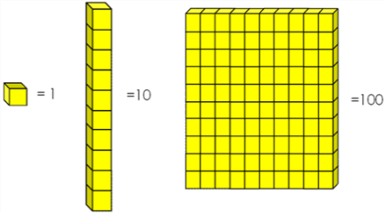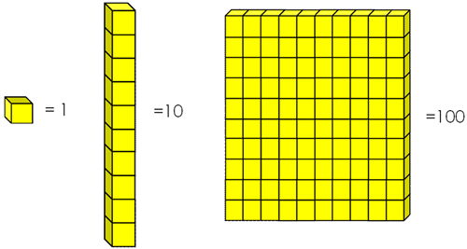

11)

 _______________



12) ______________





13)

 _________________

14) Draw base ten blocks to represent the number 230. 2.NBT.1

15) Chloe and Zein were asked to represent 141 using base ten blocks.

2.NBT.1

 Chloe: Zein:





Which student is correct? ____________________

Explain the mistake made by the other student.

__________________________________________________________________________

__________________________________________________________________________

__________________________________________________________________________

__________________________________________________________________________

__________________________________________________________________________