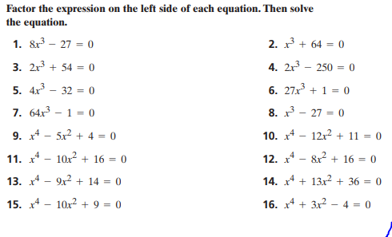  Solving Higher Order Polynomials Practice – DO WORK ON SEPARATE PAPER! | Solving Higher Order Polynomials Practice – DO WORK ON SEPARATE PAPER!
Solving Higher Order Polynomials Practice – DO WORK ON SEPARATE PAPER! | Solving Higher Order Polynomials Practice – DO WORK ON SEPARATE PAPER!

