1) Convert the following from degree measures to radian measures.

2) Convert the following from radian measures to degree measures.

3) Find the measure of an angle between 0 and 360 coterminal with the angle.

-519

4) Find the measure of an angle between 0 and 360 coterminal with the angle.

1212

5) Sketch the following angle in standard position.

-210

6) Sketch the following angle in standard position.

290

7) Find the missing sides of the special right triangle.

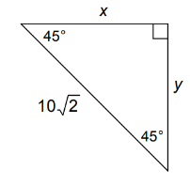

8) Find the missing sides of the special right triangle.

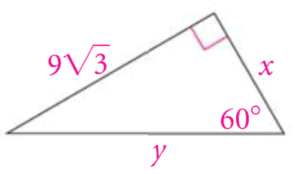

9) Find the missing sides of the special right triangle.

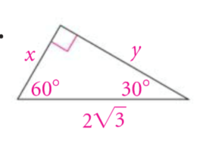

10) Find the following trig ratios. Reduce if necessary.

Sin X = Sin Z =

Cos X = Cos Z =

Tan X = Tan Z =

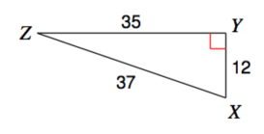

11) (a) Sketch each angle in standard position.  
 (b) Determine the reference angle.  
 (c) Sketch the reference triangle and correctly label each side.  
 (d) Find the *exact* value for the sine, cosine, and tangent of the original angle.

12) (a) Sketch each angle in standard position.  
 (b) Determine the reference angle.  
 (c) Sketch the reference triangle and correctly label each side.  
 (d) Find the *exact* value for the sine, cosine, and tangent of the original angle.