DIRECTIONS: Determine if the following graphs represent periodic functions. If not, explain why. It the graph is periodic find the period.

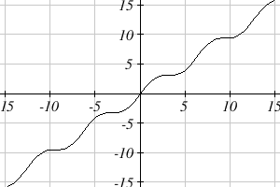  1) | 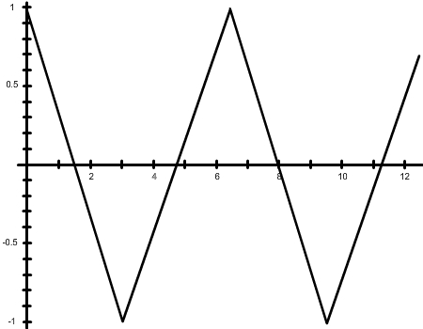  2) | 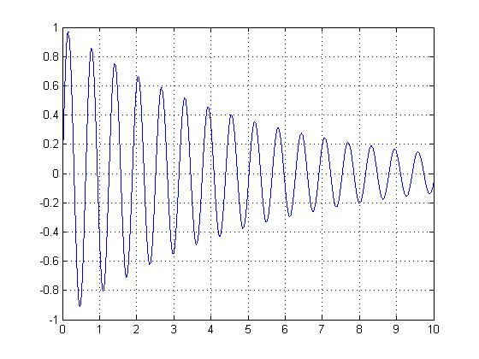  3)

DIRECTIONS: (a) Highlight one cycle of each of the following periodic graphs. (b) Find the period. (c) Find the amplitude.

4)  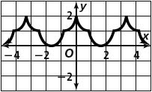 | 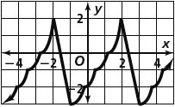  5) | 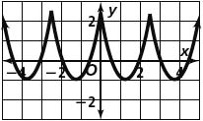  6)

DIRECTIONS: Graph one cycle of each of the following trig functions. YOU MUST INCLUDE A TABLE.

7) $y=2sinθ$ 8) $y=cos⁡(2θ)$

9) $y=-5sin⁡(πθ)$ 10) $y=-6cos\left(4θ\right)$

DIRECTIONS: Write an equation that matches the given description.

11) A positive cosine function with amplitude of 3 and period of $4π$.

12) A negative sine function with amplitude of 4 and period of 3.

13) A positive sine function with amplitude of 10 and period of $π$.

DIRECTIONS: Write an equation that satisfies the given periodic graph.

15)  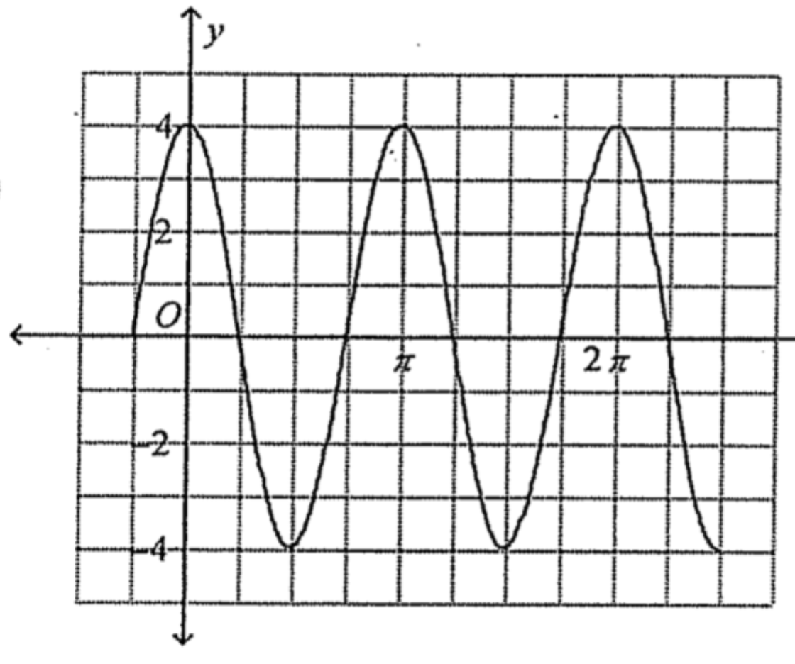 | 16) 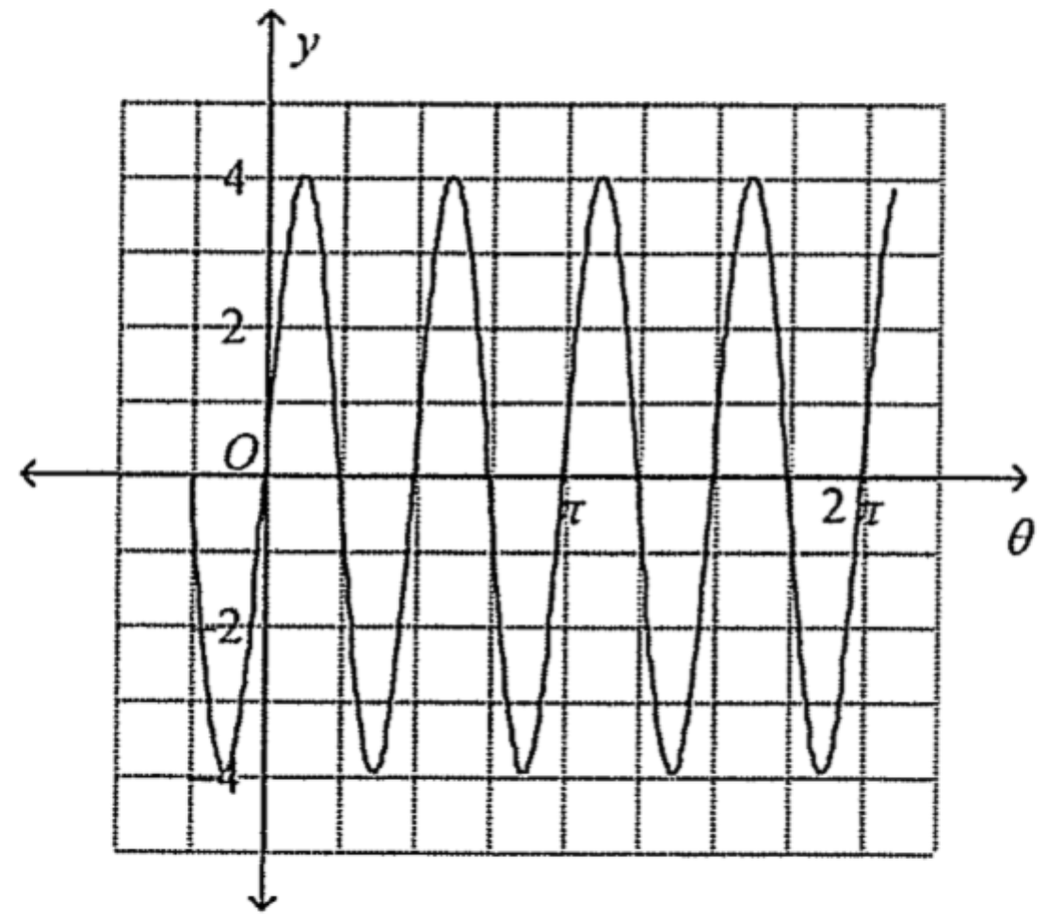 | 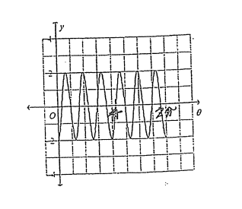  17)

