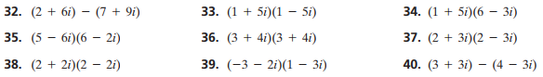

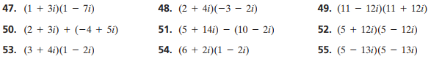

**Operations with Complex Numbers Homework –USE SEPARATE PAPER**





**Operations with Complex Numbers Homework –USE SEPARATE PAPER**





**Operations with Complex Numbers Homework –USE SEPARATE PAPER**



