Parent Functions Practice (HONORS):

**Name the parent function**

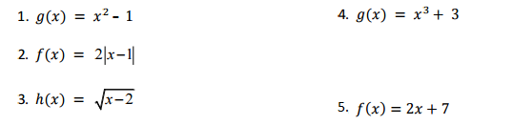

**Determine the parent function**

Parent __________________ Parent ___________________________

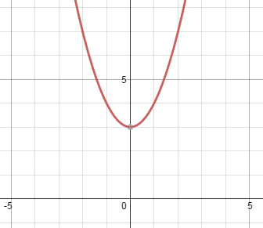 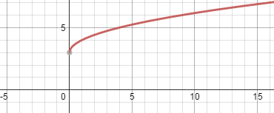

Parent __________________ Parent ___________________________

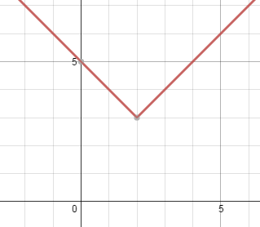 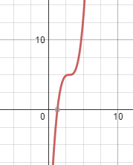

Parent __________________ Parent ___________________________

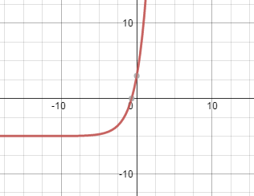 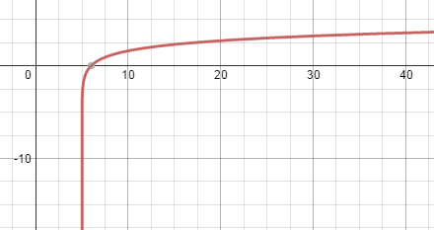

**Write the equation of the parent function on sketch its graph**

Absolute value _________________ Quadratic __________________ Exponential Growth_____________

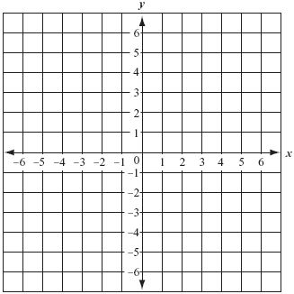

Square root __________________ Logarithmic __________________ Cubic __________________



Linear __________________ Cubic root____________________

