**How to Login to Benchmark Universe**

1. Go to the Student Portal on Dearborn Public Schools Website:

<https://dearbornschools.org/student-portal/>

2. From there click the icon that says iLearn Classrooms (it looks like a little notebook).

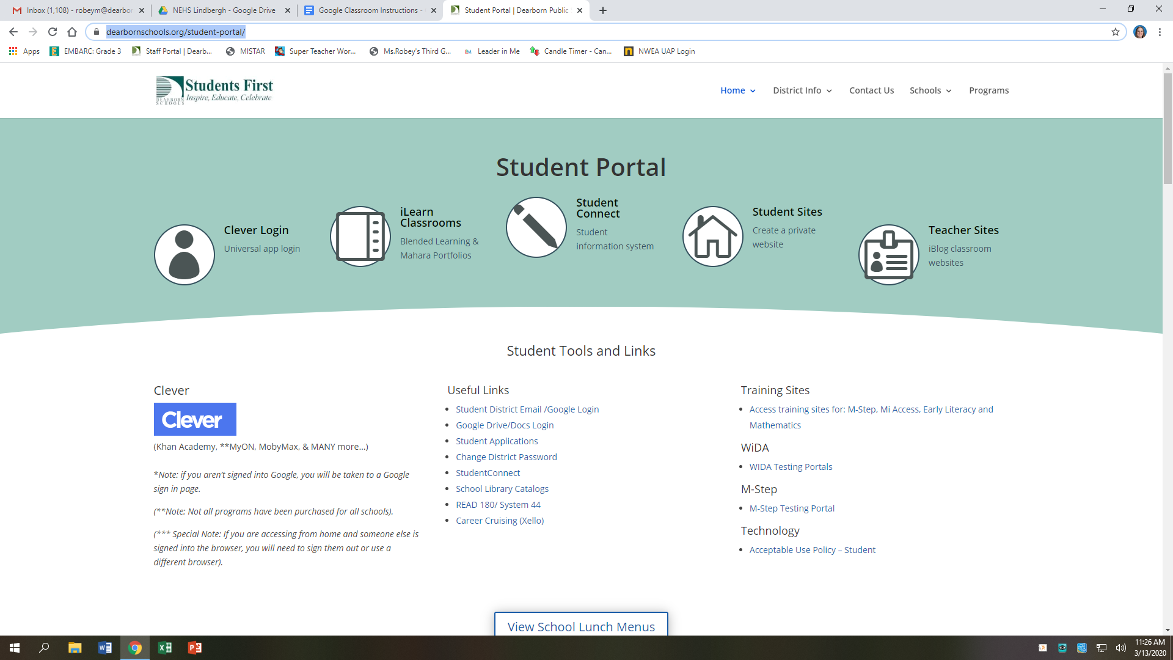

3. Once you are there, students can press the Google Button to sign in. Make sure to click your child’s district login (2000 [number@dearbornschools.org](mailto:number@dearbornschools.org)) to sign in. If that doesn’t work you may use your child’s gmail login to login to this site.

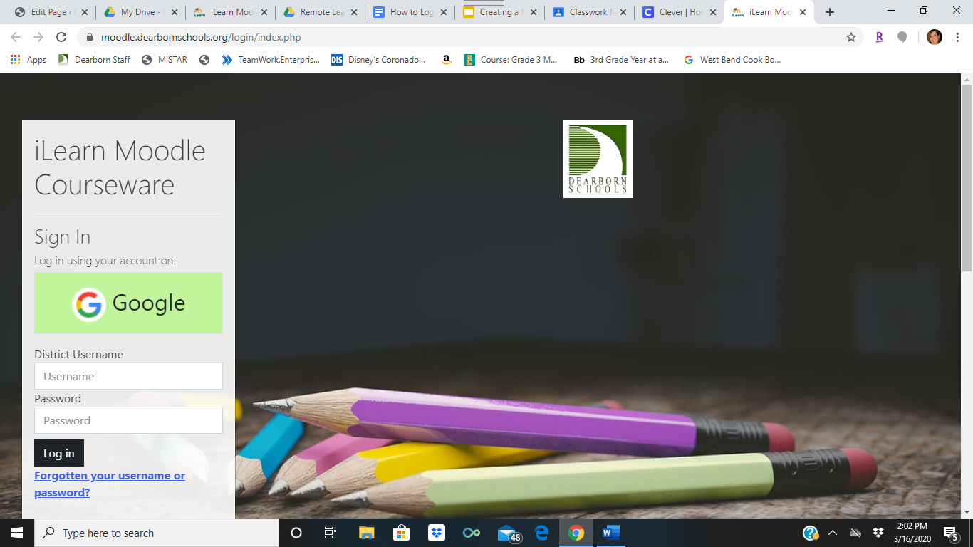

4. Once you have logged in, you need to scroll down on the homepage until you see Ms. Robey’s Reader’s Workshop class. You then will click this page.

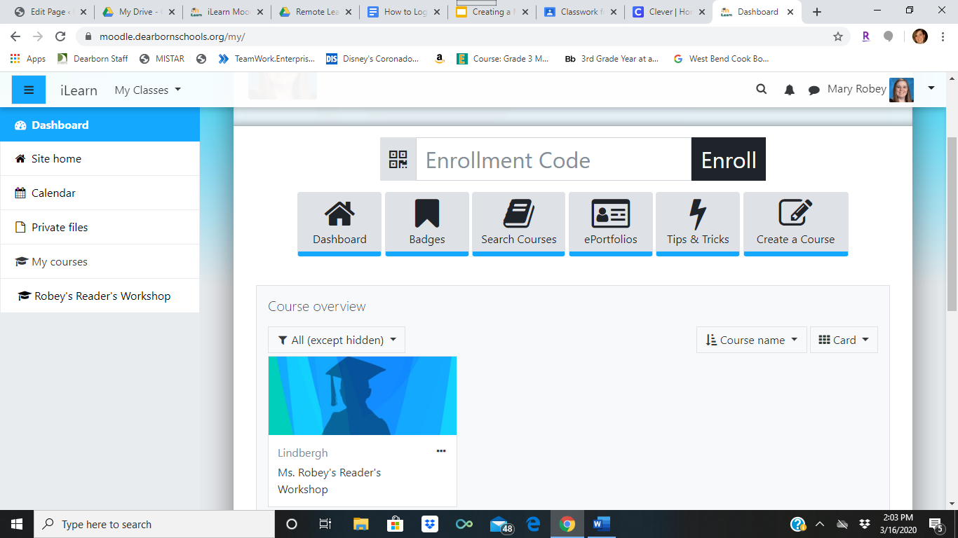

5. Once you are there, click the green cloud to access Benchmark Universe.

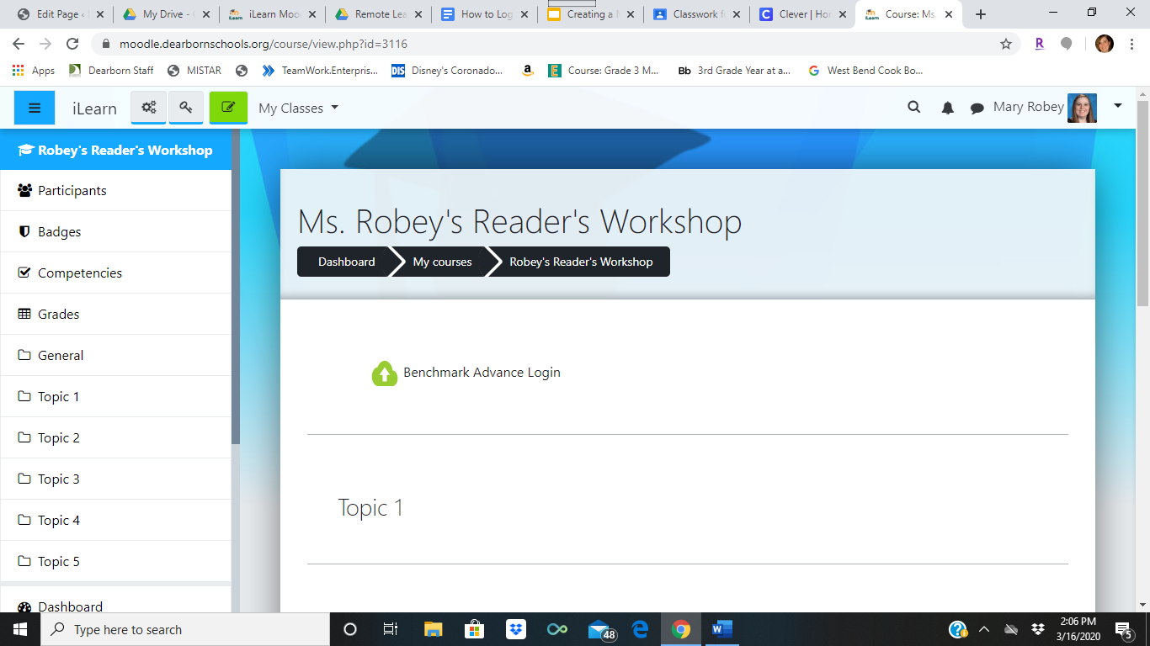

6. The student login page should look like the picture below. Once you are there, click the assignment tab to see the assignments for your child. You can also select library to see leveled readers to keep up on your reading.

