Poetry is illustrated in a creative way. The illustration has the title and author clearly written, with capital letters and punctuation where appropriate. Picture relates to the text. | Excellent | Satisfactory | Developing
 | 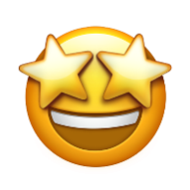3 | 2 | 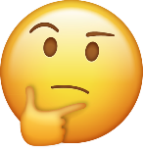1
Speaks clearly and appropriately throughout the whole entire poetry reading. | 3 | 2 | 1
Speaker has appropriate eye contact with the audience members, only looking down briefly at poem. | 3 | 2 | 1
Listens closely to peers and is able to appropriately discuss poetry performances. | 3 | 2 | 1
Is respectful to the community of learners in Ms. Robey’s Café. | 3 | 2 | 1

Name:___________________________ #_____ Date:_________________
Poetry Slam Rubric

Additional Comments:
______________________________________________________________________________________________________________________________________________________________________________________________________

