**Scent Free Zones**

Henry Ford Elementary School has been designated a Scent Free Zone because of medical conditions of students and staff members. By eliminating the use of the items below, you are helping make sure that Henry Ford is a safe environment to learn and work for all staff and students! Individuals with health concerns have strong reactions to scented items including migraines, breathing problems, shortness of breath, nausea and difficulty concentrating. Scents can also trigger a severe asthma attack.

**Products to Avoid**

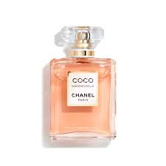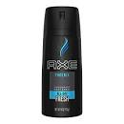 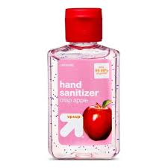 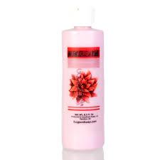 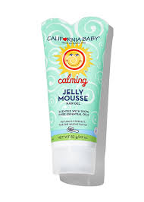 Perfumes & Cologne Scented Hand Sanitizer, Soaps, Lotions & Hair Gels

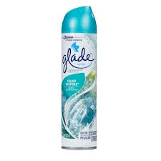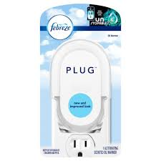 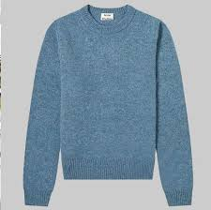

Air Freshners Clothes with perfume smell

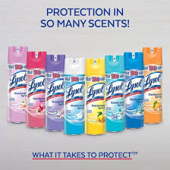

Scented Cleaning Product

The

**Sweetest** smell**…**

**…** is **NO** smell at all.



Please do your part to create a healthier environment for our students and staff by avoiding the use of perfume , cologne and scented products at Henry Ford Elementary School. Sensitivity to fragrance can cause allergies, difficulty breathing and headaches.

Thank you for your cooperation and for making Henry Ford a healthy place to work and learn!

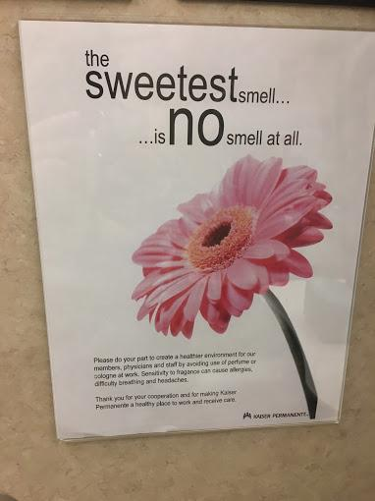

Sample I used to mock up Henry Ford note. Next slide has another version.

