Kindergarten Spelling

Week of March 11th

Test on Friday, March 15th!

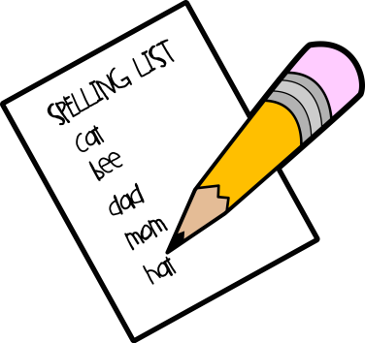

**This week’s spelling words are:**

**look**

**my**

**at**

**run**

**sun**

**Plus 2 other words from the –un family**

**(such as fun, bun, nun, etc.)**

Thank you for practicing spelling words EACH NIGHT by doing daily assignments (inside cover) in their spelling notebooks! ☺