Kindergarten Spelling

Week of February 26th

Test on Friday, March 2nd!

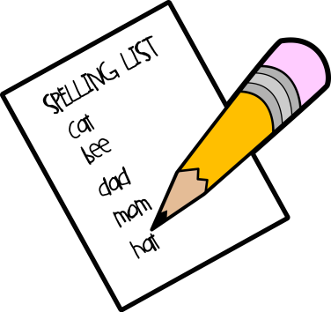

**This week’s spelling words are:**

**and**

**is**

**you**

**pig**

**big**

**Plus 2 other words from the –ig family**

**(such as jig, fig, wig, dig)**

Thank you for practicing spelling words EACH NIGHT by doing daily assignments (inside cover) in their spelling notebooks! ☺