Name __________________________________ Date ______________ Period _________
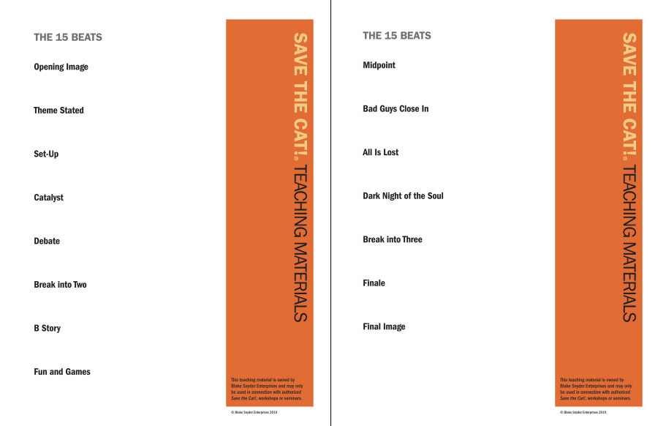
Due Monday, October 1st (10 points)

