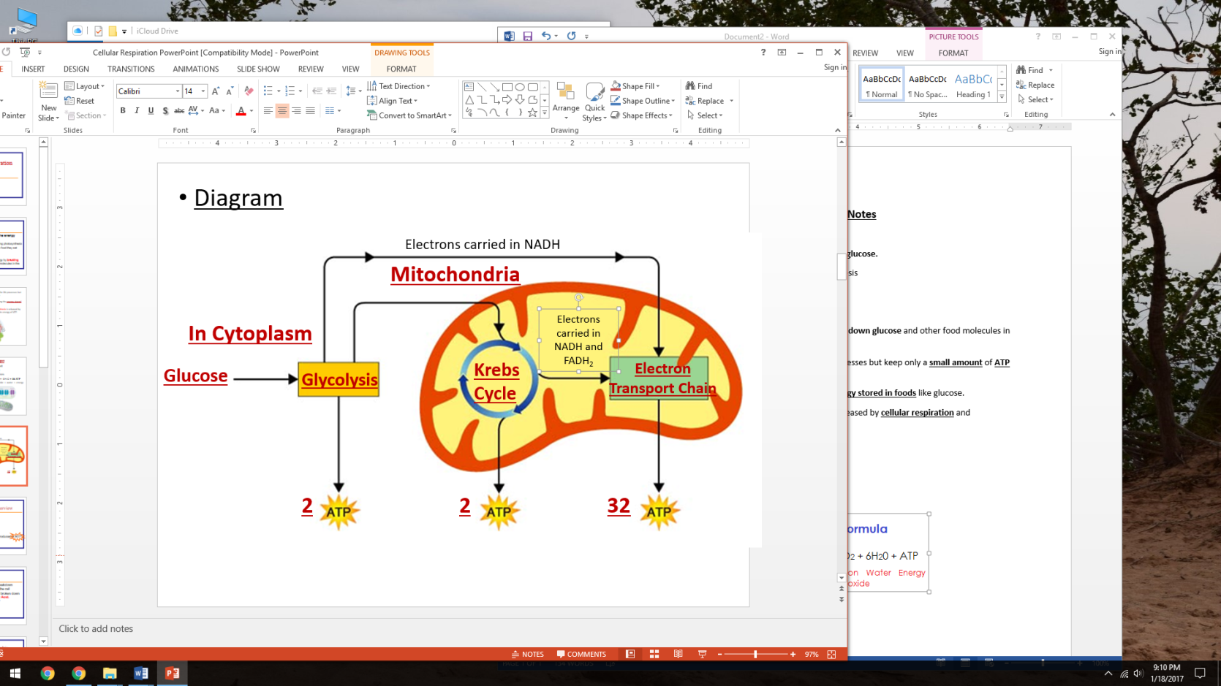**Cellular Respiration Notes**

* Living things get most of the energy they need from __________________
  + **______________________** make glucose using photosynthesis
  + **_______________________** get glucose from food they eat
* **Cellular Respiration**
  + The process that releases energy by **_________________________** and other food molecules in the **___________________________**
  + Cells require a **____________________________** for life processes but keep only a **____________________** of **________________**on hand.
  + Cells can regenerate ATP as needed by using the **________________________** like glucose.
  + The energy stored in glucose by **___________________** is released by **__________________** and repackaged into the energy of ATP.
* **Aerobic Respiration:** **____________________**
  + Occurs in the **______________________** of the cell
  + Total of **_____________** molecules produced
  + General formula for aerobic respiration:

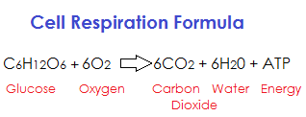

* Three Stages
* The Main form of Energy produced = ___________________

**Step 1: Glycolysis**

* Glyco = _____ lysis = Breakdown
* Occurs in the **_______________________** of the cell
* Molecules of **_________________________** are broken down into **________________________**
* Produces _____________________
* 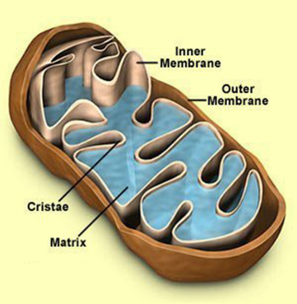The mitochondria is the **___________________** where the final stages of cellular respiration occurs.
  + Kreb’s Cycle
  + Electron Transport Chain
* Cells that use a lot of **_____________________** have high numbers of **_______________________________**
  + Example: Muscle cells in the heart!!

**Step 3: Electron Transport Chain**

* Energy carrier molecules produced during **___________________** and the **_________________________** enter the **_____________________**
* Occurs in the folds of the Inner Membrane of the **______________________** (Cristae)
* The electrons are passed down a chain of proteins until they reach the final electron acceptor…..**______________________**!
  + So this step is ______________________(requires oxygen)
* The ETC produces **_____________________________**

**Step 2: Kreb’s Cycle**

* ____________________ Process = Only if ­­­­­­­­­­­­____________________is present!!
* Occurs in the MATRIX of the mitochondria
* Pyruvic Acid from Glycolysis enters to form

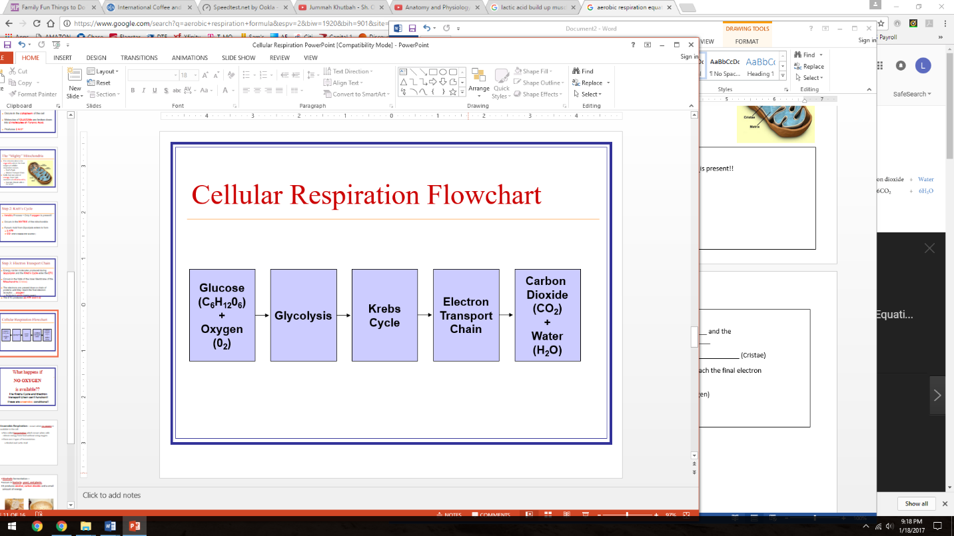

* What if no oxygen is present?
  + **Anaerobic Respiration:** occurs when **_____________________** is available to the cell
  + Also called **___________________** which occurs when cells release energy from food without using oxygen.
  + There are 2 types of fermentation:
  + 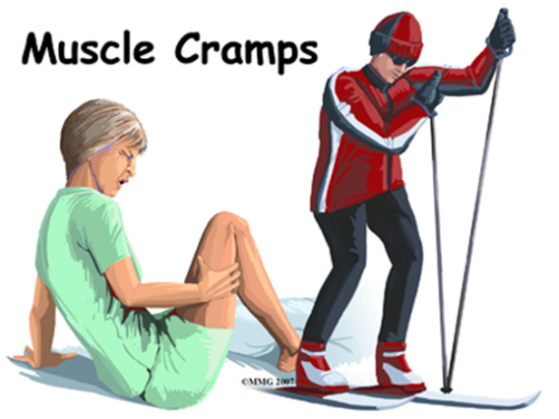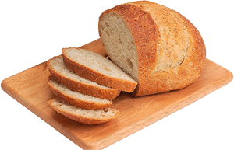**_______________________** and **______________________**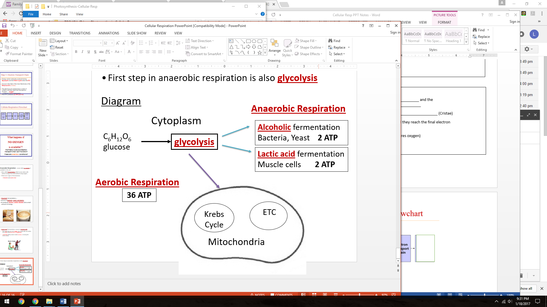

**Lactic Acid Fermentation**

* **Lactic acid** fermentation—occurs in **______________________**
* When your body runs out of **________________** your muscle cells must produce some **____________** using **___________________ and ______________**
* **Lactic Acid** build-up causes muscle **________________**or burning after intense activity.

**Alcohol Fermentation**

* **Alcoholic** fermentation—
* occurs in **__________________**, **_______________, and ______________**
* It produces **_______________, _____________________** and a small amount of energy.