CER data

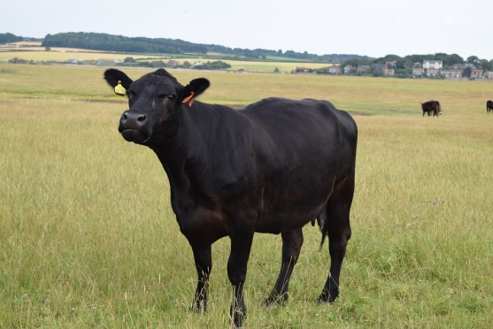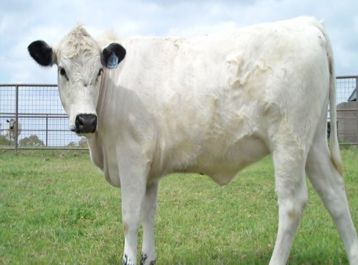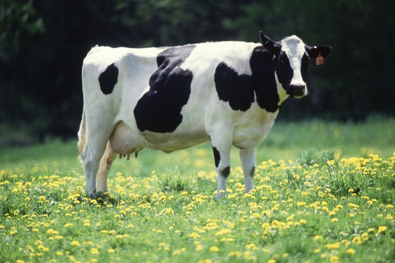

1. Cows-

|  |  |  |
| --- | --- | --- |
| black x black =  8 black cows | white x white =  9 white cows | black x white =  8 black & white cows |
| white x black =  7 black & white cows | black x black & white = 5 black and 6 black & white | white x black & white= 5 white and 4 black and white |
| black & white x black= 6 black & white and 6 black | Black & white x white= 4 black & white and 5 white | Black & white x black & white = 3 black, 5 black & white and 2 white |

What type of dominance is this? How do you know? Use CER form.

1. Flowers-

|  |  |  |
| --- | --- | --- |
| yellow x yellow = 47 yellow | red x red= 52 red | yellow x red = 49 orange |
| Red x yellow = 48 orange | yellow x orange =  24 yellow, 25 orange | red x orange =  27 red, 26 orange |
| orange x yellow =  25 yellow, 23 orange | orange x red =  25 red, 24 orange | orange x orange =  14 yellow, 24 orange, 13 red |

What type of dominance is this? How do you know? Use CER form.