
Check Your Understanding of Homologous Cells with the Smurfs

Smurfs are simple, sexually reproducing organisms. Their genome consists of nine genes distributed on three different chromosomes. The table below shows the distribution of genes on the chromosomes and the alleles Papa Smurf has for each gene.

Gene | Location of Gene | Trait on First Homolog | Trait on Second Homolog
Skin Color | Chromosome #1 | S = blue | s = white
Hat Color | Chromosome #1 | r = white | R = red
Facial Hair | Chromosome #1 | h= no beard | h = no beard
Foot Size | Chromosome #1 | f = small feet | f= small feet
Belly Button | Chromosome #2 | B= outie | B= outie
Pants | Chromosome #2 | p = red | P = yellow
Tail | Chromosome #2 | T= snub | t = long
Digits | Chromosome #3 | D= four | d = five
Eyes | Chromosome #3 | E= black | e= red

Use Papa Smurf’s Table of Genetics to complete the table below:
DOMINANT TRAITS RECESSIVE TRAITS
Gene | Genotype | Phenotype
Skin Color
Hat Color
Facial Hair
Foot Size |  | Large feet
Belly Button
Pants
Tail
Digits
Eyes
Gene | Genotype | Phenotype
Skin Color
Hat Color
Facial Hair |  | beard
Foot Size
Belly Button
Pants
Tail
Digits
Eyes

Use Papa Smurf’s Table of Genetics to complete
the table below to show Papa Smurfs characteristics
- Use Papa Smurf’s Table of Genetics to complete the diagram showing the chromosomes in one of Papa Smurf’s cells.
PAPA SMURF’sTraits | Genotype | Phenotype
Skin Color | Ss | blue
Hat Color
Facial Hair
Foot Size
Belly Button
Pants
Tail
Digits
Eyes
- Identify the homologous chromosome pairs (label 1-4). Write the chromosome # above each chromosome.
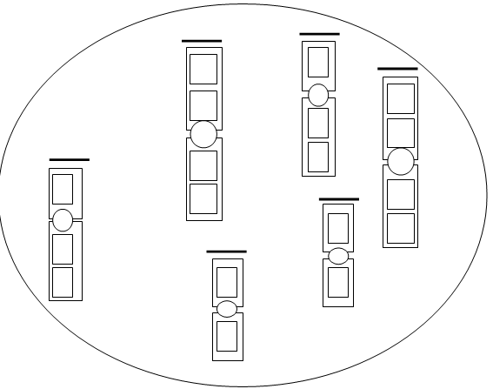
- Write in the correct trait (letters) for each gene (a box) on the chromosomes.

