DNA - The Double Helix
Recall that the nucleus is a small spherical, dense body in a cell. It is often called the "control center" because it controls all the activities of the cell including cell reproduction, and heredity. Chromosomes are microscopic, threadlike strands composed of the chemical DNA (short for deoxyribonucleic acid). In simple terms, DNA controls the production of proteins within the cell. These proteins in turn, form the structural units of cells and control all chemical processes within the cell. Think of proteins as the building blocks for an organism, proteins make up your skin, your hair, parts of individual cells. How you look is largely determined by the proteins that are made. The proteins that are made is determined by the sequence of DNA in the nucleus.
Chromosomes are composed of genes, which is a segment of DNA that codes for a particular protein which in turn codes for a trait. Hence you hear it commonly referred to as the gene for baldness or the gene for blue eyes. Meanwhile, DNA is the chemical that genes and chromosomes are made of. DNA is called a nucleic acid because it was first found in the nucleus. We now know that DNA is also found in organelles, the mitochondria and chloroplasts, though it is the DNA in the nucleus that actually controls the cell's workings.
In 1953, James Watson and Francis Crick established the structure of DNA. The shape of DNA is a double helix which is like a twisted ladder. The sides of the ladder are made of alternating sugar and phosphate molecules. The sugar is deoxyribose. Color all the phosphates (one is labeled with a "p"). Color all the deoxyriboses (one is labeled with a "D") . The sugar and phosphates are connected with strong covalent bonds.
The rungs of the ladder are pairs of 4 types of nitrogen bases. The bases are known by their coded letters A, G, T, C. These bases always bond in a certain way. Adenine will only bond to thymine. Guanine will only bond with cytosine. This is known as the "Base-Pair Rule". The bases can occur in any order along a strand of DNA. The order of these bases is the code that contains the instructions. For instance ATGCACATA would code for a different gene than AATTACGGA. A strand of DNA contains millions of bases. (For simplicity, the image only contains a few.)
Use the key on the paper to indentify the nucleotide parts by color.
Color the thymines.  Color the adenines. 
Color the guanines.  Color the cytosines. 
Note that that the bases attach to the sides of the ladder at the sugars and not the phosphate.
The DNA helix is actually made of repeating units called nucleotides. Each nucleotide consists of three molecules: a sugar (deoxyribose), a phosphate which links the sugars together, and then one of the four bases. Two of the bases are purines - adenine and guanine. The pyrimidines are thymine and cytosine. Note that the pyrimidines are single ringed and the purines are double ringed. Color the nucleotides using the same colors as you colored them in the double helix.
The two sides of the DNA ladder are held together loosely by hydrogen bonds. The DNA can actually "unzip" when it needs to replicate - or make a copy of itself. DNA needs to copy itself when a cell divides, so that the new cells each contain a copy of the DNA. Without these instructions, the new cells wouldn't have the correct information. The hydrogen bonds are represented by small circles. Color the hydrogen bonds.
Messenger RNA
So, now, we know the nucleus controls the cell's activities through the chemical DNA, but how? It is the sequence of bases that determine which protein is to be made. The sequence is like a code that we can now interpret. The sequence determines which proteins are made and the proteins determine which activities will be performed. And that is how the nucleus is the control center of the cell. The only problem is that the DNA is too big to go through the nuclear pores. So a chemical is used to read the DNA in the nucleus. That chemical is messenger RNA. The messenger RNA (mRNA) is small enough to go through the nuclear pores. It takes the "message" of the DNA to the ribosome and "tells them" what proteins are to be made. Recall that proteins are the body's building blocks. Imagine that the code taken to the ribosome is telling the ribosome what is needed - like a recipe.
Messenger RNA is similar to DNA, except that it is a single strand, and it has no thymine. Instead of thymine, mRNA contains the base Uracil. In addition to that difference, mRNA has the sugar ribose instead of deoxyribose. RNA stands for Ribonucleic Acid. Color the mRNA as you did the DNA, except:
Color the ribose (one is labeled “R”), and the uracil shown as .
The Blueprint of Life
Every cell in your body has the same "blueprint" or the same DNA. Like the blueprints of a house tell the builders how to construct a house, the DNA "blueprint" tells the cell how to build the organism. Yet, how can a heart be so different from a brain if all the cells contain the same instructions? Although much work remains in genetics, it has become apparent that a cell has the ability to turn off most genes and only work with the genes necessary to do a job. We also know that a lot of DNA apparently is nonsense and codes for nothing. These regions of DNA that do not code for proteins are called "introns", or sometimes "junk DNA". The sections of DNA that do actually code from proteins are called "exons".

DNA - The Double Helix and RNA

Name
1. Write out the full name for DNA. _____________________________________________
What does the D stand for?________________________ which is a _____________________.
2. What is a gene? _______________________________________________________
3. Where in the cell are chromosomes located? ________________________________________
4. DNA can be found in what two organelles? ____________________, ______________________
5. What two scientists established the structure of DNA? _____________________________________
6. What is the shape of DNA? ______________________________________
7. What are the sides of the DNA ladder made of? ________________________________________
8. What are the "rungs" of the DNA ladder made of? _______________________________________
9. What sugar is found in DNA? _______________________ In RNA? ____________________
10. How do the bases bond together? A bonds with _____ G bonds with _______
11. The two purines in DNA are _____________________, ___________________________.
12. DNA is made of repeating units called _____________________________________________
The two sides of the DNA ladder are held together ___________ by ______________________.
13. Why is RNA necessary to act as a messenger? Why can't the code be taken directly from the DNA?

14. Proteins are made where in the cell? ______________________________
15. How do some cells become brain cells and others become skin cells, when the DNA in ALL the cells is exactly the same? In other words, if the instructions are exactly the same, how does one cell become a brain cell and another a skin cell?

16. Why is DNA called the "Blueprint of Life"?

Name __________________________________
Color the images according to the instructions.
DNA  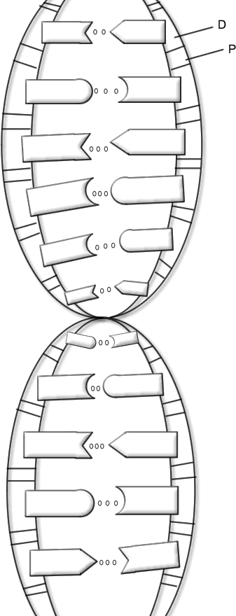 | 