Bell work #3 9/9/16
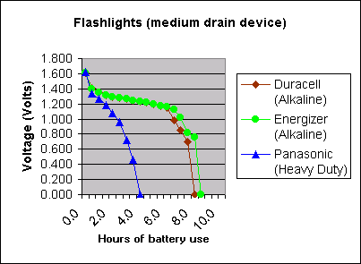

- Locate the X-axis. Voltage or Hours?

- Locate the Y-axis. Voltage or Hours?

- What is the independent variable?
- What is the dependent variable?

Learning Target: I can collect the data that is appropriate for the question that I am testing.

