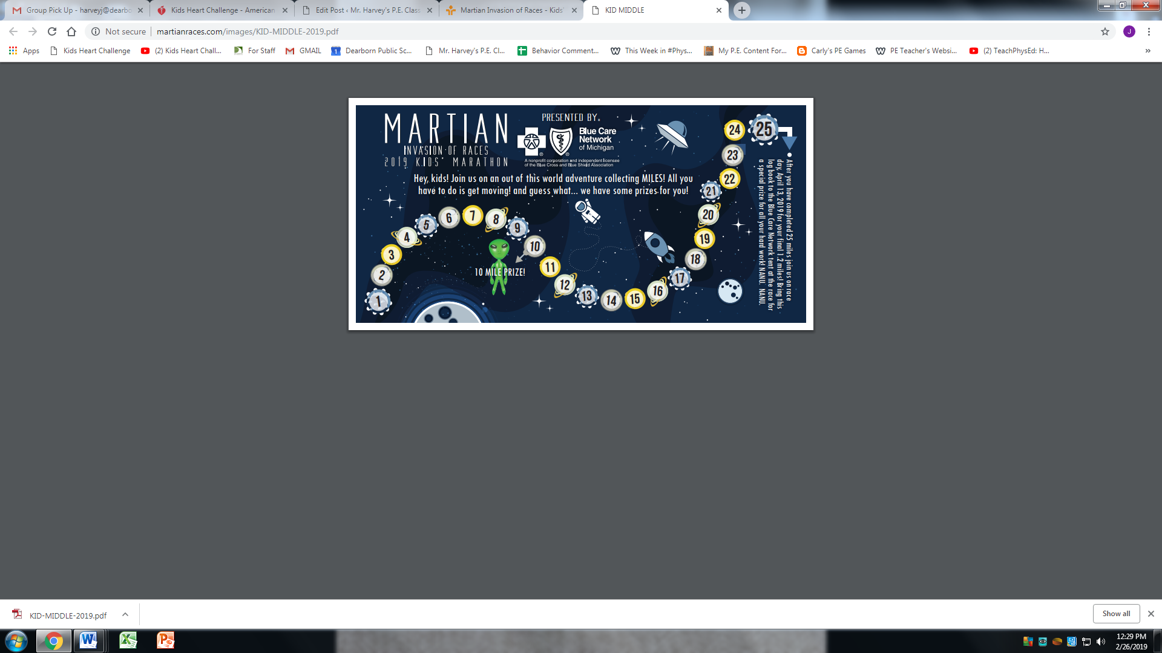**Name: _____________________ Teacher: __________________________**