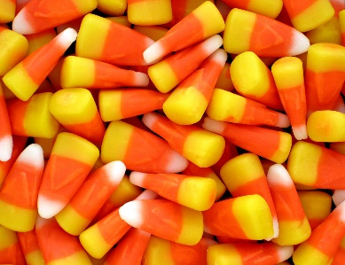

Halloween Candy Corn Tower Challenge

October 25, 2017

Dear Parents,

Next Tuesday, October 31st, our class will be participating in a Candy Corn Tower Challenge as part of our Science curriculum/Halloween Party.

Please send 100 toothpicks and 1 cup of candy corns with your child on Monday, October 30th. We will use them for our project on Tuesday, October 31st.

Feel free to come and assist the students that day☺

The festivities will begin around 1:40. At 1:40 we will need parent volunteers to help the kids change into their costumes. Then our candy corn challenge will begin around 2 and last until around 3.

Also, a simple treat like a sugar cookie, a piece of candy, and a juice box would be acceptable to have sometime during this time if you’d like to volunteer to send that in. Please respond on the dojo if you would be sending something like that in so we don’t get too much. Please let me know if you have any questions.

Sincerely,

Gina Parana