**Top 20 Wealthiest Americans**

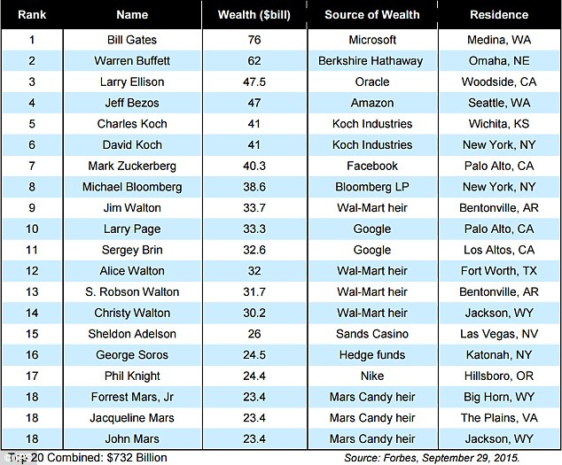

[The Forbes 400](http://www.forbes.com/forbes-400/list/#version:realtime)