Directions:

1 – Highlight areas which confuse you and about which you want clarification.

2 – Demonstrate evidence of a close reading, by providing reactions, questions, and mini-summaries

**Unions, teachers targeted in anti-sickout bills**

[Jonathan Oosting, Detroit News Lansing Bureau](http://www.detroitnews.com/staff/10046778/jonathan-oosting) 10:52 a.m. EST February 2, 2016

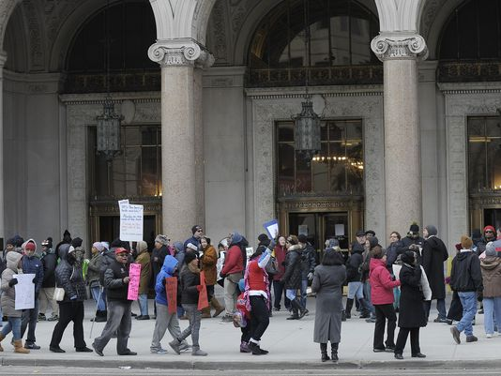

(Photo: Clarence Tabb Jr. / The Detroit News)

*Lansing* — Unions could be decertified, their leaders fined and teachers suspended under advancing state legislation designed to crack down on mass sickouts in the Detroit Public Schools.

“I think that there’s an organization that’s keeping kids from the classroom,” sponsoring Senate Education Committee chair Phil Pavlov, R-St. Clair Township, said after his anti-sickout bill advanced to the floor in a 4-1 vote.

Pavlov said his bill addresses “a glaring hole” in state law that makes it illegal for teachers to strike. It would speed up an existing process for the Michigan Employment Relations Commission to determine whether a sickout amounted to a strike, and it would penalize participants.

New provisions added in committee would temporarily freeze union dues collection and bar the incumbent bargaining unit from representing teachers for five years in a district where a strike occurred.

“We’re trying to make sure the kids are getting a good education, and that requires teachers being in the classroom,” Pavlov said.

Ivy Bailey, interim president of the Detroit Federation of Teachers, testified against the legislation and said the union did not play any role in organizing the sickouts that have led to the closure of dozens of city schools in recent months.

“There’s a bigger picture here — they want to destroy unions, plain and simple,” Bailey told The Detroit News. “They don’t want to have people with collective bargaining rights, but the thing that really infuriates me is it’s always when Detroit teacher speak up.”

Bailey was among a handful of union leaders, parents and other advocates who praised teachers for drawing attention to “deplorable” conditions in Detroit schools.

She testified alongside David Hecker, president of the American Federation of Teachers-Michigan, who held up oversized pictures showing a dead rat and a roof leak in two Detroit schools.

“They’re refusing to deal with the real issues of what we need to do to address the issues that teachers and the DFT has brought to light regarding the problems in Detroit,” Hecker said of the GOP bill sponsors. “There are building problems, oversized classrooms, lack of supplies and unhealthy conditions in so many of our schools.”

The sickout protests were organized by ousted DFT union president Steve Conn. Current leadership did not help organize, according to Hecker and Bailey, who nonetheless supported the teacher actions.

“There were discussions with people that maybe this wasn’t the best strategy,” Hecker said of the sickouts, “but people did what people did because of their frustration because of what they’ve had to deal with.”

Under Pavlov’s bill, union leaders would face a $5,000 fine for each day of a sickout and teachers would lose their pay if the Michigan Employment Relations Commission determined strike conditions were met. The commission would have two days, as opposed to 60 under current law, to hold a hearing and consider strike allegations.

Companion legislation introduced by Sen. Joe Hune, R-Hamburg, would withhold school aid funding to a district that fails to deduct a fine from an employee’s paycheck.

Another bill sponsored by Sen. Dave Robertson, R-Grand Blanc, would require the state superintendent to suspend for two years the teaching certificate of any teacher found to have engaged in a strike. Teachers would first have the right to an administrative hearing.

Hecker called the bills “unconstitutional,” saying they would deny teachers free speech and due process guarantees.

Sen. Patrick Colbeck, R-Canton, said he was sensitive some of the concerns voiced by Detroit teachers but said they could raise those issues without shutting down schools.

“It doesn’t make any sense. There’s other times of day you can go off and protest,” Colbeck said. “They chose deliberately to go off and protest in a way that made the very people they’re supposed to serve hurt the most, and I’m struggling with that.”

Sen. David Knezek, the lone Democrat on the committee, compared the proposed sickout penalties to the state’s initial dismissal of water contamination concerns in Flint.

“When the teachers brought to light the conditions in the Detroit Public Schools, our first response is to try to punish those teachers?” said Knezek, D-Dearborn Heights. “To me, that is contrary to the type of state government we are running — one that should be responsive to those needs and looking for solutions rather than punishing the whistle-blowers.”

The sickout debate could complicate Gov. Rick Snyder’s efforts to help Detroit Public Schools crawl out from under crippling debt, much of which the state could be liable for if the district folds.

The Senate Government Operations Committee, chaired by Majority Leader Arlan Meekhof, R-West Olive, will meet Thursday to begin discussing the Detroit schools rescue plan.

Pavlov said he is not yet sure when the full Senate might take up the sickout legislation. The Republican caucus has not yet discussed the bills, he told reporters.

joosting@detroitnews.com

Directions for reflections:

Write three one-paragraph reflections, each one placing the issue in a different context. Label each paragraph according to its context. Choose from the list of contexts below:

Cultural Health & Safety Social

Academic Generational Economic

Historical Religious Environmental

Political Moral Medical

Gender Legal Self-expression