University of Missouri president leaves over race complaints; Northville graduate among the players

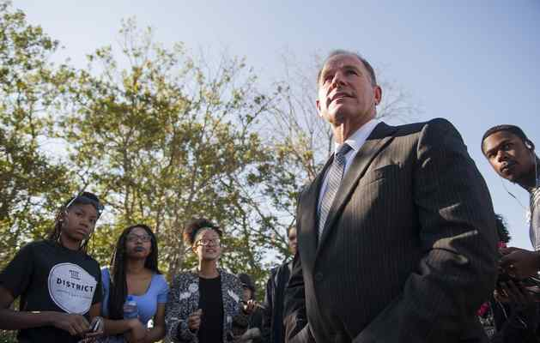
In a Tuesday, Nov. 3, 2015 photo, University of Missouri President Tim Wolfe speaks with members of Concerned Student 1950 senior Abigail Hollis, from left, senior DeShaunya Ware and junior Shelbey Parnell as they call for Wolfe's resignation outside University Hall on the University of Missouri campus, in Columbia, Mo. Wolfe resigned Monday, Nov. 9, 2015, amid criticism of handling of racial issues. (Daniel Brenner/Columbia Daily Tribune via AP)

POSTED: 11/09/15, 12:15 PM EST

COLUMBIA, Mo. (AP) — The president of the University of Missouri system stepped down Monday amid criticism of his handling of student complaints about race and discrimination.

President Tim Wolfe said his resignation was effective immediately. He made the announcement at the start of what had been expected to be a lengthy closed-door meeting of the school’s governing board. He largely pre-empted that session in a halting statement that was simultaneously apologetic, clumsy and defiant.

“This is not the way change comes about,” he said, alluding to recent protests. “We stopped listening to each other.”

He urged students, faculty and staff to “use my resignation to heal and start talking again to make the changes necessary.”

A poor audio feed for the one board member who was attending the meeting via conference call left Wolfe standing awkwardly at the podium for nearly three minutes after only being able to read the first sentence of his statement.

The race complaints came to a head over the weekend when at least 30 black football playersannounced they would not participate in team activities until Wolfe was gone.

Trey Walton, a senior defensive back from Northville, supported the efforts.

“Honored to be standing with my teammates,” Walton (@QTrei) tweeted Sunday as news of the intended boycott spread and referencing one student’s hunger strike. “My family! #ConcernedStudent1950 #hungerstrike.”

For months, black student groups have complained of racial slurs and other slights on the overwhelmingly white flagship campus of the state’s four-college system. Frustrations flared during a homecoming parade Oct. 10 when black protesters blocked Wolfe’s car, and he did not get out and talk to them. They were removed by police.

Black members of the football team joined the outcry on Saturday night. By Sunday, a campus sit-in had grown in size, graduate student groups planned walkouts and politicians began to weigh in.

Until Monday, Wolfe did not indicate that he had any intention of stepping down. He agreed in a statement issued Sunday that “change is needed” and said the university was working to draw up a plan by April to promote diversity and tolerance.

The Tigers’ next game is Saturday against Brigham Young University at Arrowhead Stadium, the home of the NFL’s Kansas City Chiefs, and canceling it could cost the school more than $1 million.

“The athletes of color on the University of Missouri football team truly believe ‘Injustice Anywhere is a threat to Justice Everywhere,’” the players said in a statement. “We will no longer participate in any football related activities until President Tim Wolfe resigns or is removed due to his negligence toward marginalized students’ experience. WE ARE UNITED!!!!!”

Head football coach Gary Pinkel expressed solidarity on Twitter, posting a picture of the team and coaches locking arms. The tweet said: “The Mizzou Family stands as one. We are united. We are behind our players.”

Walton retweeted his coach’s tweet.

Practice and other team activities were canceled Sunday. A statement issued by Pinkel and Missouri athletic director Mack Rhoades linked the return of the protesting football players to the end of a hunger strike by a black graduate student who began the effort Nov. 2 and has vowed to not eat until Wolfe is gone.

“Our focus right now is on the health of Jonathan Butler, the concerns of our student-athletes and working with our community to address this serious issue,” the statement said.

The protests began after the student government president, who is black, said in September that people in a passing pickup truck shouted racial slurs at him. In early October, members of a black student organization said slurs were hurled at them by an apparently drunken white student.

Also, a swastika drawn in feces was found recently in a dormitory bathroom.

Many of the protests have been led by an organization called Concerned Student 1950, which gets its name from the year the university accepted its first black student. Its members besieged Wolfe’s car at the parade, and they have been conducting a sit-in on a campus plaza since last Monday.

Two trucks flying Confederate flags drove past the site Sunday, a move many saw as an attempt at intimidation. At least 150 students gathered at the plaza Sunday night to pray, sing and read Bible verses, a larger crowd than on previous days. Many planned to camp there overnight, despite temperatures that had dropped into the upper 30s.

Also joining in the protest effort were two graduate student groups that called for walkouts Monday and Tuesday and the student government at the Columbia campus, the Missouri Students Association.

The association said in a letter Sunday to the system’s governing body that there had been “an increase in tension and inequality with no systemic support” since last year’s fatal shooting of Michael Brown in Ferguson, which is about 120 miles east of Columbia.
Brown, an unarmed black 18-year-old, was shot and killed by a white police officer during a struggle, and his death helped spawn the “Black Lives Matter” movement rebuking police treatment of minorities.

The association said Wolfe heads a university leadership that “has undeniably failed us and the students that we represent.”

“He has not only enabled a culture of racism since the start of his tenure in 2012, but blatantly ignored and disrespected the concerns of students,” the group wrote.
Concerned Student 1950 has demanded, among other things, that Wolfe “acknowledge his white male privilege,” that he is immediately removed, and that the school adopt a mandatory racial-awareness program and hire more black faculty and staff.

One of the sit-in participants, Abigail Hollis, a black undergraduate, said the campus is “unhealthy and unsafe for us.”

“The way white students are treated is in stark contrast to the way black students and other marginalized students are treated, and it’s time to stop that,” Hollis said. “It’s 2015.”

The school’s undergraduate population is 79 percent white and 8 percent black. The state is about 83 percent white and nearly 12 percent black.

Wolfe, 56, is a former software executive and Missouri business school graduate whose father taught at the university. He was hired in 2011 as president, succeeding another former business executive who also lacked experience in academia.

Lawmakers and elected officials began to weigh in Sunday. The chairman of a Missouri House higher education committee, Republican Rep. Steven Cookson, said in a statement that Wolfe “can no longer effectively lead” and should leave his post.

Joining him in calling for Wolfe’s resignation was Assistant House Minority Leader Gail McCann Beatty, the highest-ranking black member of that chamber.

