**My Seminar Goal: ________________________________________ Name: __________________________**

**Socratic Seminar Notes: __/__/20___**

**Coaching Tally Sheet:** Record the number of times that your partner engages in each of the following:

**Poses a question** 

**Summarizes another’s comment** 

**Extends an idea** 

**Interrupts** 

**Looks at the speaker** 

**References the text** 

**Clarifies an idea/question** 

**Track the discussion:** Record big ideas from the conversation. This will help your “halftime talk” to focus on ideas that your partner could surface, on questions that could be asked.

**Socratic Seminar Reflection**

**What I learned:** Before the seminar I thought…

_________________________________________________________________________________________

_________________________________________________________________________________________

_________________________________________________________________________________________

After the seminar I thought… (Did your opinion change or stay the same? Why?)

_________________________________________________________________________________________

_________________________________________________________________________________________

_________________________________________________________________________________________

**Consider the following questions as you prepare to talk about the strengths of our seminar and the area for growth.**

**Did the participants…**

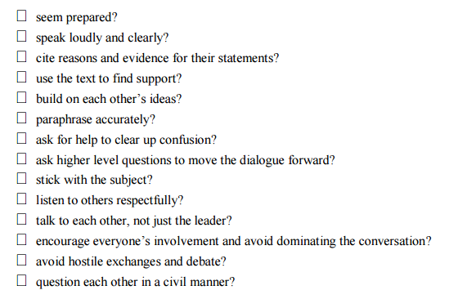

**What really worked:** Describe a part of the seminar that you thought went well. What made it work?

_________________________________________________________________________________________

_________________________________________________________________________________________

_________________________________________________________________________________________

_________________________________________________________________________________________

**Self-Evaluation:** Check all that apply to your efforts to prepare for and participate in today’s seminar (this is not graded)

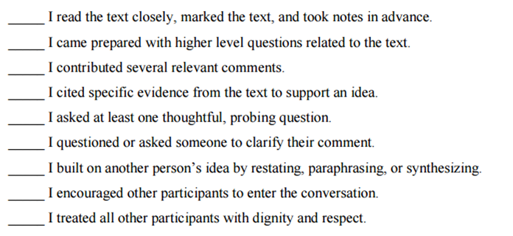

**What I did:** What’s something that you wish you had said during the discussion or something that you contributed that you are proud of? Explain your reasoning.

_________________________________________________________________________________________

_________________________________________________________________________________________

_________________________________________________________________________________________

_________________________________________________________________________________________

**Suggestions for next time:** Based on your preparation and performance today, what is your personal goal for our next Socratic seminar?

_________________________________________________________________________________________

_________________________________________________________________________________________

_________________________________________________________________________________________

Our class goal is ____________________________________________________________________________

_________________________________________________________________________________________

“[The unexamined life is not worth living.](http://www.brainyquote.com/quotes/quotes/s/socrates101168.html)”

[**Socrates**](http://www.brainyquote.com/quotes/quotes/s/socrates101168.html)