Visual Aids:

Why Use Them?

--Visual Aids can make your ideas clear and understandable
--Speech on production of dollar bills
--Visual Aids can make your speech more interesting
--Travelogue
--Visual Aids can help the audience remember facts and details
--Maps
--Visual Aids can make long, complicated explanations unnecessary
--Coaches during time-outs
--Visual Aids can help prove a point
--Dropping a camera to show durability
--Visual Aids can add to your personal credibility
--Make you appear more or LESS professional

TYPES:

Graphs:
--Line Graphs: Horizontal and Vertical scale; good to show trends and changes

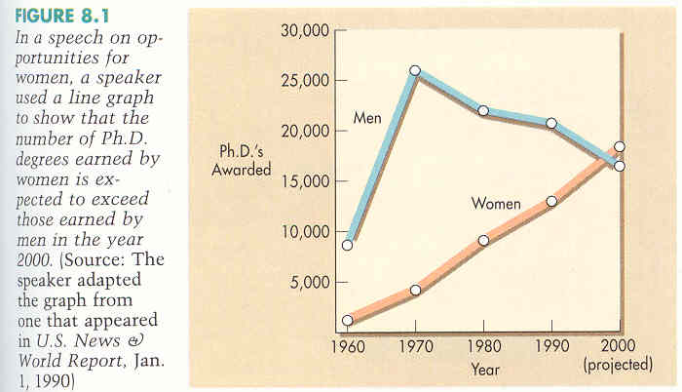

--Bell-shaped curve: Statistical information in a graphic way

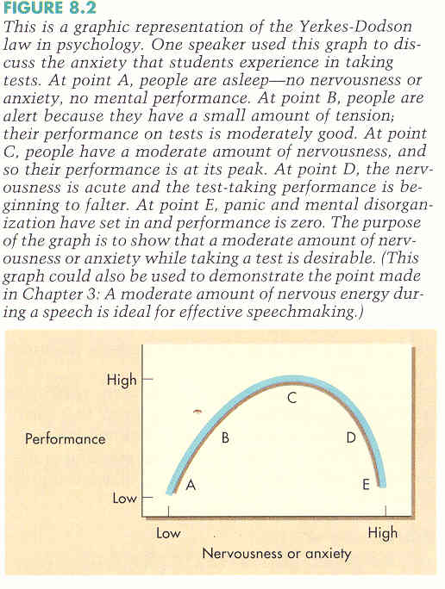

--Pie graph: Circle representing 100% to show divisions
--Not too many pieces!

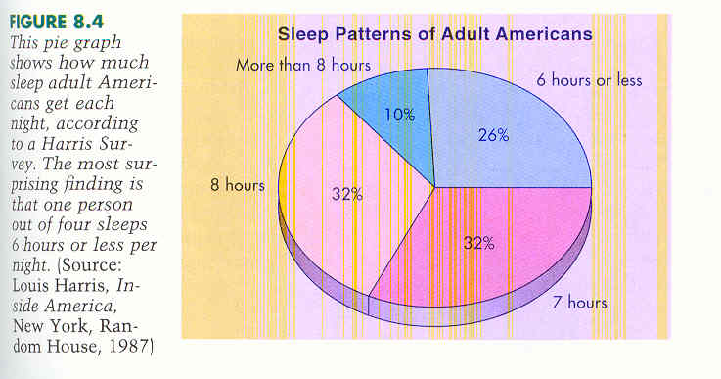

--Bar Graph: Good to show relationships and comparisons

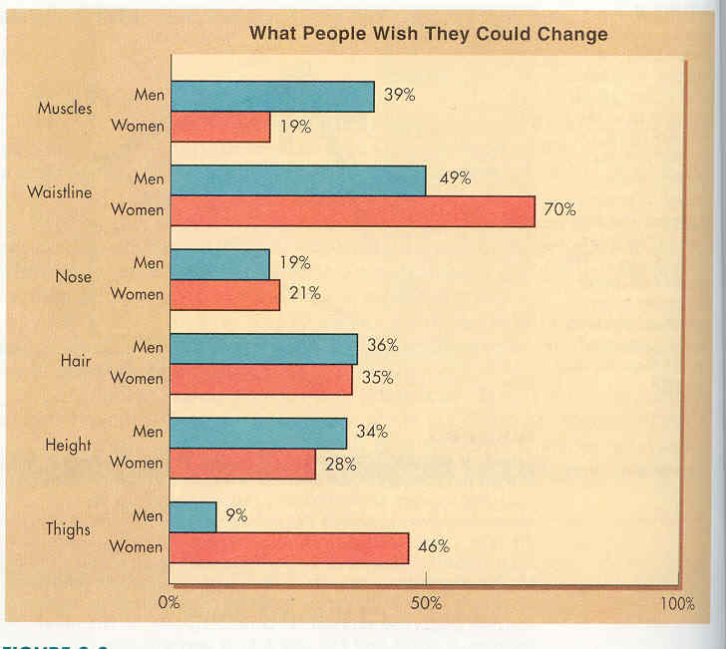

--Pictograph: Represents units of things with pictures

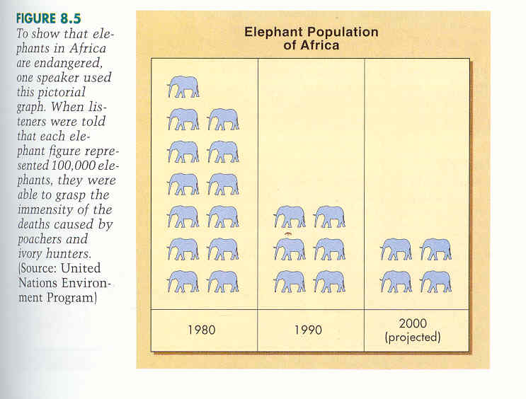

Charts:
--Organizational Chart: Shows a hierarchy (like a family tree)

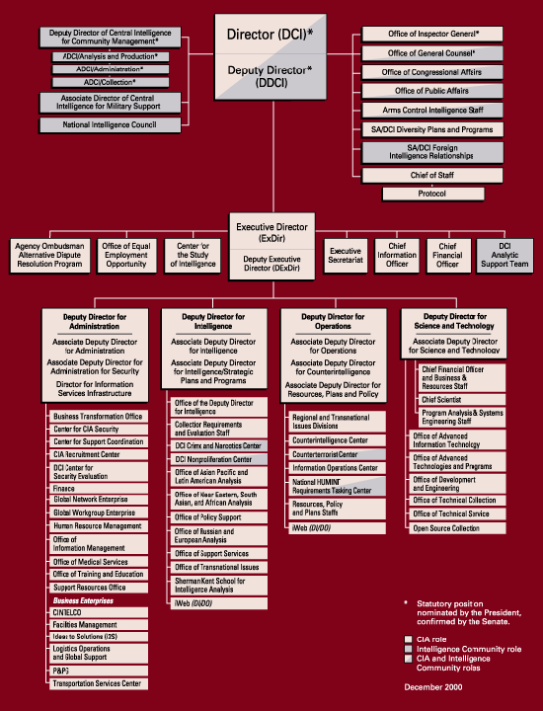

--Flow Chart: Good to show a sequence of events

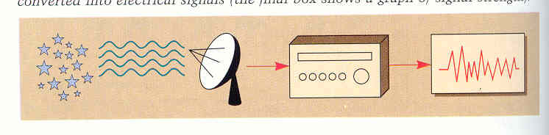

--Information Chart (LIST): Good for stimulating audience participation (we love lists)
--Tables are good examples

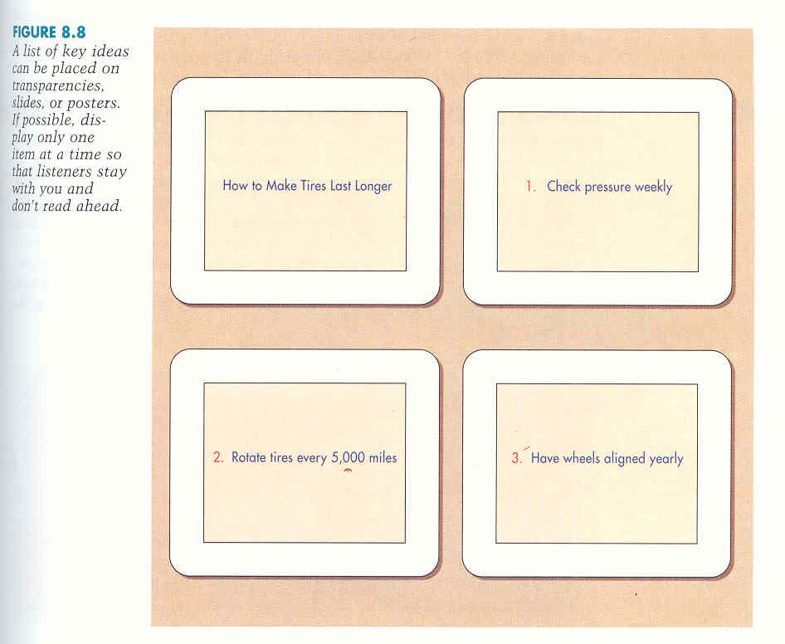

Drawings:
--Demonstrate a process visually

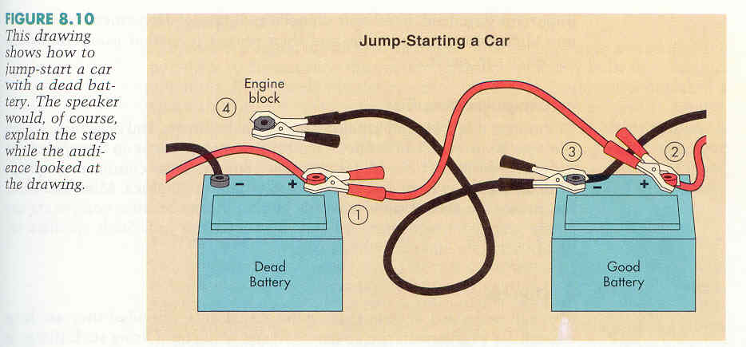

Maps:
--Can show specific information (highlighting all the McDonald’s)

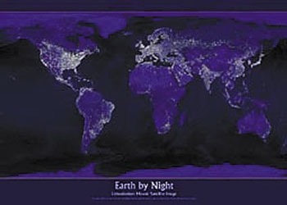

--Can show relationships in space

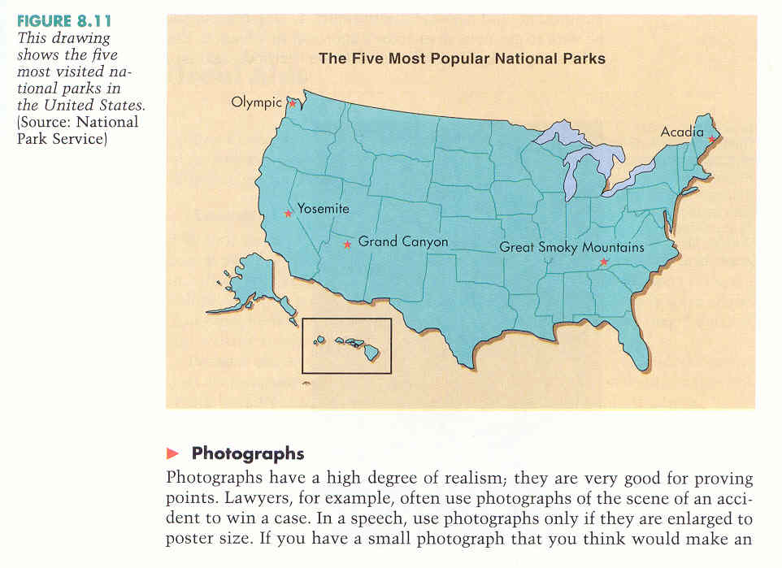

Photographs:
--Very realistic
--Must be poster size
--Can be scanned and projected
--Can be enlarged using photoshop; watch resolution

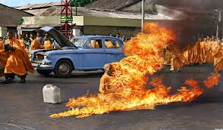

Computer Graphics:
--Photoshop, Pagemaker, AutoCAD, Etc….

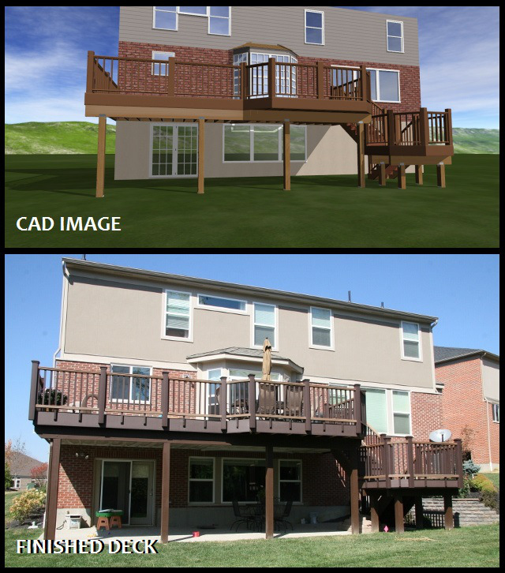

Objects:
--Three-dimensional objects: Musical instruments, snakes, people, etc.

Models: Physical representation of an object
--Architectural models for presentations (like in Fordson’s library for the new wing)

You: Movement, Dress, etc.

MEDIA:
--Boards (chalk or white)
--Careful about turning your back
--Don’t have it up early to distract the audience
--Light it correctly to reduce glare
--Have it prepared ahead of time

--Posters
--Must be READABLE from the back of the room
--Put in a reliable place
--Easel
--Tacked to the wall
--Never just leaning on the chalk ledge
--Materials:
--Firm and solid – foam core boards
--Flip charts
--large spiral bound notebooks that can be flipped up and over on an easel
--can be prepared ahead of time
--can be revealed incrementally

--Handouts
--DON’T DISTRIBUTE EARLY
--Keep it short and simple
--easy to understand
--SMALL amount of text
--Don’t discuss the handout until everyone has it
--If complex info or lengthy info, give out AFTER the question and answer period or class period

--Overhead transparencies:
--Advantages:
--Simple to make
--Can make last-minute changes
--Can operate the machine alone
--Room can usually be lit
--Don’t have to turn your back on the audience

--Prepare them ahead of time
--Make artwork and letters large enough to see from a long distance
--Use overhead pens (Not permanent markers)!

--Powerpoint
--Advantages:
--Can be multimedia
--music, movies, pictures, charts, graphs, colors, etc
--Very flexible
--can alter the rate and the presentation during the speech
--Modern
--we’re fools for technology
--Problems
--Computer malfunction
--Projector malfunction
--Too many bells and whistles can distract
--Can be labor intensive to create

--Videotapes/DVDs/YOUtube (etc.)
--Advantages:
--Can demonstrate a process
--Can hold listener attention
--We’re fools for TV

--Problems
--Malfunctioning equipment
--Need large enough TV
--Can’t check for listener comprehension as it goes
--Rules:
--Don’t let it do your talking FOR YOU
--Use small segments rather than the whole speech or tape

--ELMO/Document Camera
--Advantages:
--Can make small media or physical media visible from a distance
--Allow you to demonstrate a small or intricate process from a distance

--Problems:
--Can limit your eye contact
--Can limit your gesture
--Can require you to be seated
--Requires a data projector

GENERAL GUIDELINES:
--Truly support your speech
--prepare in advance and practice with it
--don’t use too many
--Make it simple and clear
--Neatness counts
--Large enough to see
--Explain them, even if they seem self-explanatory
--Don’t let them distract from your message
--Show one at a time
--Beware of kids and animals
--chek you’re speling
--Never circulate a visual aid
--Don’t talk to the vis. Aid
--Use progressive revelation
--Have a back-up plan
--EXTRA BATTERIES, etc.

