Directions:

1 – Highlight areas which confuse you and about which you want clarification.

2 – Demonstrate evidence of a close reading, by providing reactions, questions, and mini-summaries

**Toys R Us puts 'Breaking Bad' figures on 'sabbatical'**

By **Todd Leopold**, CNN

updated 6:09 PM EDT, Thu October 23, 2014

**(CNN)** -- "Breaking Bad's" drug-dealing chemistry teacher Walter White will have to stop making the sale at Toys R Us.

The toy store chain won't be selling "Breaking Bad" action figures anymore thanks in part to [an online petition](http://www.change.org/p/toys-r-us-remove-breaking-bad-dolls-from-their-shelves) that urged the store to pull them from their stores and online site. The petition, issued by Susan Schrivjer of Fort Myers, Florida, received more than 9,000 signatures.

"Let's just say, the action figures have taken an 'indefinite sabbatical,' " Toys R Us said in a statement.

[Mother wants 'Breaking Bad' action figures removed from Toys R Us](http://www.cnn.com/2014/10/20/living/breaking-bad-action-figures-toys-r-us-protest/index.html)

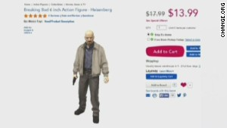*Bryan Cranston responds to upset mom*

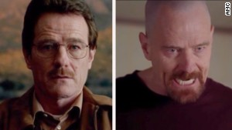*The evolution of Walter White*

Schrivjer's petition had picked up plenty of media coverage. Even Walter White himself, actor [Bryan Cranston, weighed in, tweeting](https://twitter.com/BryanCranston/status/524255816724275200), " 'Florida mom petitions against Toys 'R Us over Breaking Bad action figures.' I'm so mad, I'm burning my Florida Mom action figure in protest."

[Cranston was back Wednesday](https://twitter.com/BryanCranston/status/524943370356269056) after Toys R Us put out its statement.

"Toys R Us puts Breaking Bad toys on 'indefinite sabbatical.' Word on the street is that they were sent to Belize. Nicely played Florida Mom," he tweeted.

His co-star, Aaron Paul, got in a gibe at the expense of another figure in his own tweet, which went out Thursday afternoon.

"Wait, so @ToysRUs pulled all of the Breaking Bad figures from their shelves and still sells Barbie? Hmmmm...I wonder what is more damaging?" wrote Paul.

He then posted another, more pointed, tweet.

"And what about all of the violent video games you sell @ToysRUs ? Do you still sell those? Florida mom really messed it up for everyone," [he wrote](https://twitter.com/aaronpaul_8/status/525397537193074688).

Using the name Susan Myers on Change.org, Schrivjer had noted the store's "selection of toys for children of all ages." However, she added, "their decision to sell a Breaking Bad doll, complete with a detachable sack of cash and a bag of meth, alongside children's toys is a dangerous deviation from their family friendly values."

On Wednesday, the petition webpage had a "Victory" symbol at the top.

Schrivjer [told CNN affiliate WFTX of Fort Myers](http://www.jrn.com/fox4now/news/Mom-thinks-Breaking-Bad-is-sending-wrong-message-to-kids-279229312.html) that she likes "Breaking Bad," the show. But seeing the action figures at Toys R Us was just too much.

"Kids mimic their action figures, if you will," she told the station. "Do you want your child in an orange jumpsuit?"

Directions for reflections:

Write three one-paragraph reflections, each one placing the issue in a different context. Label each paragraph according to its context. Choose from the list of contexts below:

Cultural

Academic

Historical

Political

Gender

Health & Safety

Generational

Religious

Moral

Legal

Social

Economic

Environmental

Medical

Self-expression