Directions:
1 – Highlight areas which confuse you and about which you want clarification.
2 – Demonstrate evidence of a close reading, by providing reactions, questions, and mini-summaries

The Interview: Sony shelves worldwide release

18 December 2014 Last updated at 11:22 ET

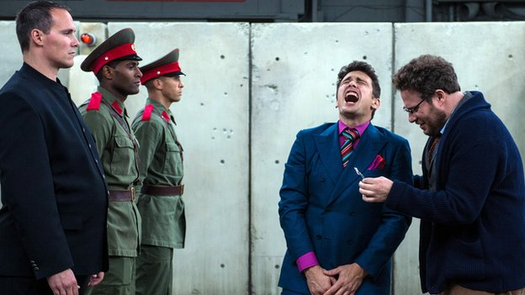
Comic caper The Interview stars James Franco and Seth Rogen

Sony has confirmed it has no plans to release the satirical film The Interview internationally, in any form, following threats from hackers.
Cinemas in the US cancelled screenings of the film, about a plot to kill North Korea's leader, prompting Sony to shelve it altogether.

But there has been dismay in Hollywood, with Ben Stiller calling the move "a threat to freedom of expression".

Hackers had issued a warning to cinema-goers who planned to watch the movie.

President Obama recommended that "people go to the movies", but stressed that the hack was "very serious".

Speaking to US television network ABC, he added: "We'll be vigilant - if we see something that we think is serious and credible, then we'll alert the public."

Sony had little choice but to bow to the demands of the hackers, says the BBC's Alastair Leithead.

Several other famous names have criticised the decision to shelve the movie, accusing the studio of caving in to the hackers' threats.

Oscar-wining screenwriter Aaron Sorkin, who has already attacked the media for spreading information leaked by the hackers, said: "Today the US succumbed to an unprecedented attack on our most cherished, bedrock principle of free speech."

Actor Steve Carell called the move a "sad day for creative expression".

On Wednesday it emerged that Carell's planned film project, a thriller called Pyongyang about a Westerner working in North Korea, was scrapped ahead of Sony's announcement.

Sony's decision to pull the release of The Interview is viewed by industry insiders as a game changer.

Films have been pulled from cinemas before, but the set of circumstances around The Interview are unprecedented.

One of the best known cases was when Stanley Kubrick withdrew A Clockwork Orange from British cinemas in 1973 after protests about the violence in the film. It was unseen in UK cinemas for 27 years.

Sony's decision came after major US cinema chains had yanked the film from their Christmas schedules over security fears.

What's surprised some is why Sony pulled the film completely. It has confirmed there are no further release plans, including on DVD or a VOD launch - which would have helped recoup The Interview's estimated $42m (£27.5m) budget.
In recent years, studios have had to take tough decisions due to unforeseen circumstances.

Following a mass shooting in a Colorado cinema during a 2012 screening of The Dark Knight Rises, US cinemas tightened security and Warner Bros scaled down its promotional plans. The film went on to box office success.

But in the case of The Interview, it looks as if it will not be coming to a cinema near you any time soon.

Comedian Jimmy Kimmel tweeted that the decision by theatres to refuse to show the film was "an un-American act of cowardice that validates terrorist actions and sets a terrifying precedent."
Film producer Judd Apatow, meanwhile, offered a different slant on the move, saying: "This only guarantees that this movie will be seen by more people on earth than it would have before. Legally or illegally all will see it."

David Oyelowo - who plays Martin Luther King in the film Selma - says he can understand why Sony have made the decision

'Extremely disappointed'

Sony said it was "deeply saddened at this brazen effort to suppress the distribution of a movie".

"We respect and understand our partners' decision and, of course, completely share their
paramount interest in the safety of employees and theatre-goers," the studio said.

]It added: "We stand by our film-makers and their right to free expression and are extremely disappointed by this outcome."

The cancellation comes after hackers calling themselves Guardians of Peace released emails and data stolen from Sony in late November.

In a later warning to cinemas screening The Interview, they referred to the 9/11 attacks, claiming "the world will be full of fear".
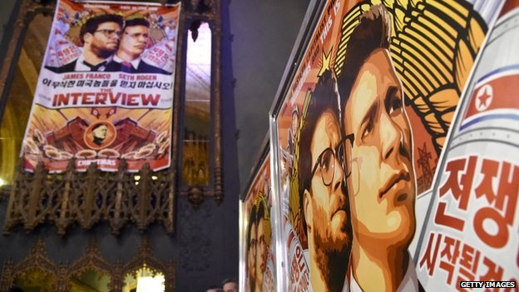
Stars of The Interview have pulled out of media appearances.

"Remember the 11th of September 2001. We recommend you to keep yourself distant from the places at that time," the hacker group wrote, in a message on Tuesday.

"Whatever comes in the coming days is called by the greed of Sony Pictures Entertainment."

Sony had given theatres in the US and Canada the option to bow out of showing The Interview in the wake of the threats.

Regal Cinemas, AMC Entertainment and Cinemark Theatres - the top three theatre chains in North America - subsequently announced they were postponing screenings, and Canada's biggest theatre firms also pulled out, leaving Sony seemingly no choice but to postpone the film.

However, the Alamo Drafthouse cinema in Texas has decided to replace The Interview with a screening of Team America, a film featuring a marionette of late North Korean leader Kim Jong-il, the father of Kim Jong-un.
//
Directions for reflections: Write three one-paragraph reflections, each one placing the issue in a different context. Label each paragraph according to its context. Choose from among the list of contexts: Cultural, Health & Safety, Academic, Historical, Political, Gender, Generational, Religious, Moral, Legal, Social, Economic, Environmental, Medical, and Self-expression

