Statistics Create an extended frequency distribution for each data set.

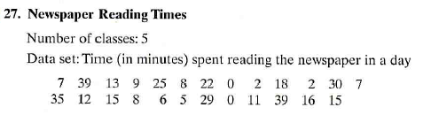

Find class width here:

|  |  |  |  |  |  |  |
| --- | --- | --- | --- | --- | --- | --- |
| Class | Tally | Freq. | Midpoint | Relative Freq. | Cumulative Freq. | Class boundaries |
|  |  |  |  |  |  |  |
|  |  |  |  |  |  |  |
|  |  |  |  |  |  |  |
|  |  |  |  |  |  |  |
|  |  |  |  |  |  |  |

 

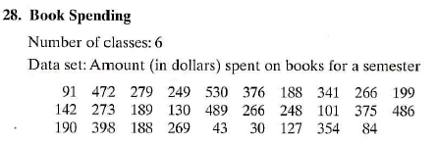

Find class width here:

|  |  |  |  |  |  |  |
| --- | --- | --- | --- | --- | --- | --- |
| Class | Tally | Freq. | Midpoint | Rel. Freq. | Cumulative Freq. | Class boundaries |
|  |  |  |  |  |  |  |
|  |  |  |  |  |  |  |
|  |  |  |  |  |  |  |
|  |  |  |  |  |  |  |
|  |  |  |  |  |  |  |
|  |  |  |  |  |  |  |

 

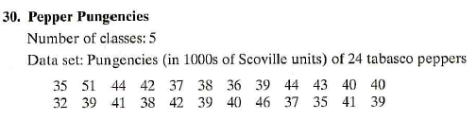

Find class width here:

|  |  |  |  |  |  |  |
| --- | --- | --- | --- | --- | --- | --- |
| Class | Tally | Freq. | Midpoint | Relative Freq. | Cumulative Freq. | Class boundaries |
|  |  |  |  |  |  |  |
|  |  |  |  |  |  |  |
|  |  |  |  |  |  |  |
|  |  |  |  |  |  |  |
|  |  |  |  |  |  |  |

 





Find class width here:

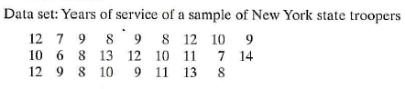

|  |  |  |  |  |  |  |
| --- | --- | --- | --- | --- | --- | --- |
| Class | Tally | Freq. | Midpoint | Relative Freq. | Cumulative Freq. | Class boundaries |
|  |  |  |  |  |  |  |
|  |  |  |  |  |  |  |
|  |  |  |  |  |  |  |
|  |  |  |  |  |  |  |
|  |  |  |  |  |  |  |

 