Geometry Review for Section 6.5 Date: _________________

Before we continue our notes for chapter 6, we need to do some review of essential ideas about right triangles.

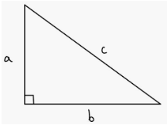
Part I: Review of Pythagorean Theorem
FORMULA: Recall the Pythagorean Theorem is used to find missing sides of __________________________.

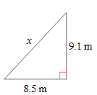
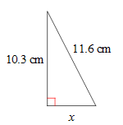
1. x = __________ 2. x = __________

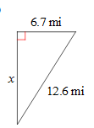
3. x = __________ 4. x = __________
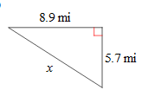

In the next 2 sections of Chapter 6, we are going to be studying special types of parallelograms:
_____________________, ____________________, and ____________________.
Let’s look at some other properties of rectangles.
Find the perimeter of each rectangle.
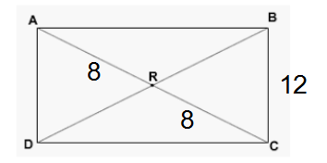
5.

6.
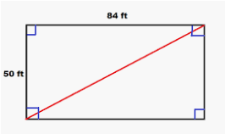

Find all the missing angles in Rectangle ABCD.
7.
