Geometry 6.1-6.3 Giant Review Name: ___________________________

Fill in the formula used to find each

|  |  |
| --- | --- |
| 1. Sum of the interior angles of a polygon: |  |
| 2. Sum of the exterior angles of a polygon: |  |
| 3. Each interior angle of a regular polygon can be found by: |  |
| 4. Each exterior angle of a regular polygon can be found by: |  |

Fill in the missing information in the table below.

|  |  |  |  |  |  |
| --- | --- | --- | --- | --- | --- |
|  | **# of sides** | **Interior angle sum** | **Measure of ONE interior angle in a regular polygon** | **Exterior angle sum** | **Measure of ONE exterior angle if a regular polygon** |
| 5. | 12 |  |  |  |  |
| 6. | 18 |  |  |  |  |
| 7. |  |  |  |  |  |
| 8. |  |  |  |  |  |
| 9. |  |  |  |  |  |
| 10 |  |  |  |  |  |
| 11. |  |  |  |  |  |
| 12. |  |  |  |  |  |

13. Find the value of x. 14. Find the value of x and 2x.

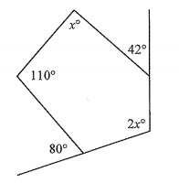

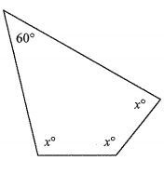

15. Find the value of each variable.

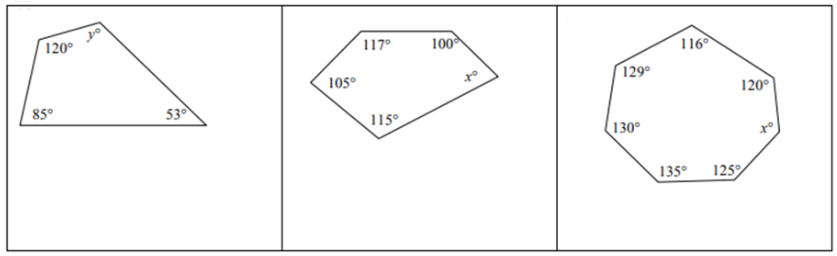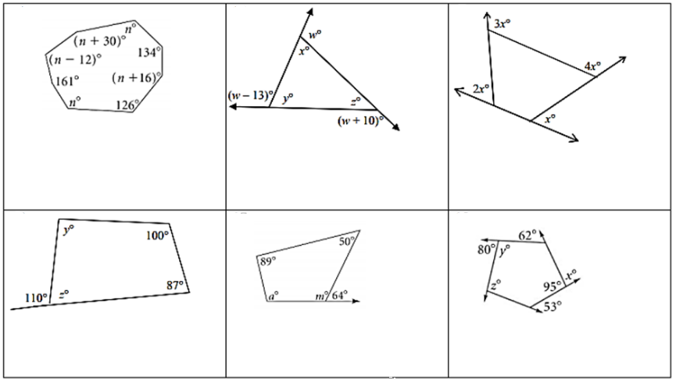

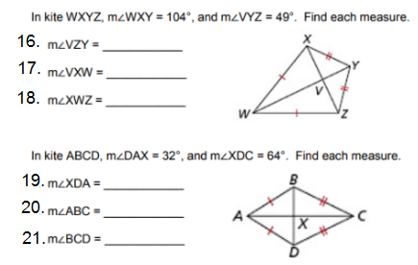

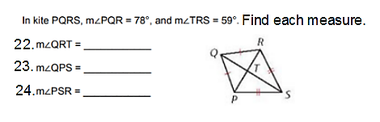

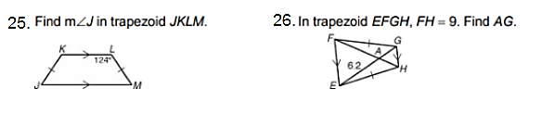

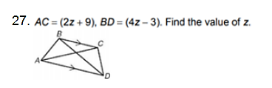

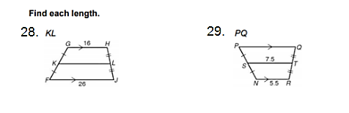

Find the value of each variable in each parallelogram.

30. a = _______ b = _______ 31. x = _______ y = _______

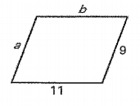 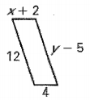

32. x = ________ y = ________ 33. f = ________ g = ________

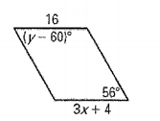 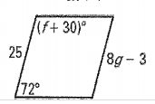

34. m = _______ n = ________ 35. j = ________ k = ________

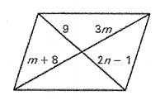 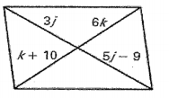

Fill in the blank with the appropriate word or phrase.

36. In a parallelogram, opposite sides are ___________________ and ____________________.

37. In a parallelogram, opposite angles are ______________________.

38. In a parallelogram, consecutive angles are ______________________.

39. In a kite, the diagonals are _______________________.

40. In an isosceles trapezoid, the base angles are _____________________.

41. In an isosceles trapezoid, the consecutive angles are _____________________.