Geometry 6.1-6.2 Bellwork Name: __________________________

Find the interior angle sum for the polygon below.

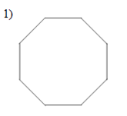

Find the measure of ONE interior angle of the regular polygon below.

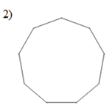

Find the measure of ONE exterior angle in the regular polygon below.

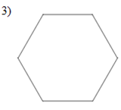

Find the length of KL in the trapezoid below.

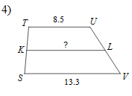

Find the missing angle in the isosceles trapezoid.

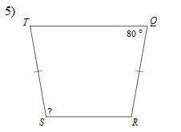

Find the length of the diagonal indicated in the isosceles trapezoid below.

