Geometry Topic 3: Dilations Homework Name: ___________________________

1. Draw a dilation of scale factor 0.5. Write the coordinates of the pre-image and image below.
Then write a transformation rule.
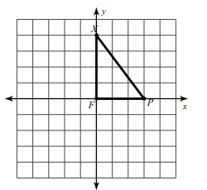
Coordinates
X __________ X’ __________
F __________ F’ __________
P __________ P’ __________
Rule: ___________________________

2. Draw a dilation of scale factor 2. Write the coordinates of the pre-image and image below.
Then write a transformation rule.
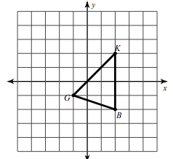
Coordinates
G __________ G’ __________
K __________ K’ __________
B __________ B’ __________
Rule: ___________________________

Write a rule to describe each transformation.
3. Rule: _________________________ 4. Rule: _________________________
