College Concepts Chapter 3 review #2 Name: _________________________

**Solve each equation for y.**

1.  2.  3. 

4. Graph  5. Graph 

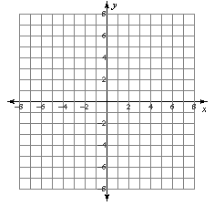



6. Graph and label each point below. 7. Identify the coordinates of each

A(-2, 0) B(3, -4) point graphed below.

C(0, 6) D(-3, -1) A ________ B ________

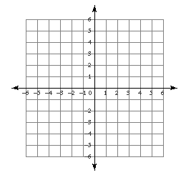 C ________ D ________

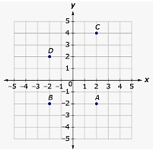

**Solve each equation.**

8.  9. 

10. Find the x- and y-intercepts. Then graph the line. 11. Graph the line: 





12. Find the slope of the line that contains the points (-3, 5) and (2, 5).

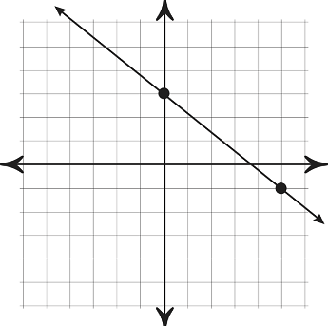13. Find the slope of the line graphed at the right.

The slope is _______

14. Use the graph for a – c.

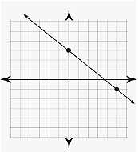

a) What is the slope of the line?

b) What is the y-intercept of the line?

c) What is the equation of the line?