College Concepts 3.4 Additional Review Name: ___________________________

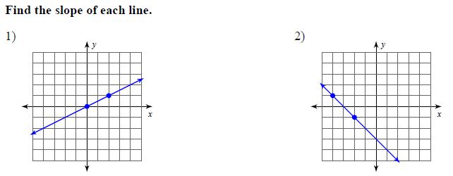

Find the slope of each line. Identify a slope that is parallel and perpendicular.

Slope = Slope =
Parallel = Parallel =
Perpendicular = Perpendicular =

5. Determine if the lines passing through the given pairs of points are parallel, perpendicular, or neither.
(-1, -7) and (2, 5) ; )-4, 0) and (4, 2)

