Station 1:
Read the paragraphs below and answer the questions
- Define meiosis.
- What are gametes?
- What are human gametes?
- What is a zygote?
- What occurs during Interphase?
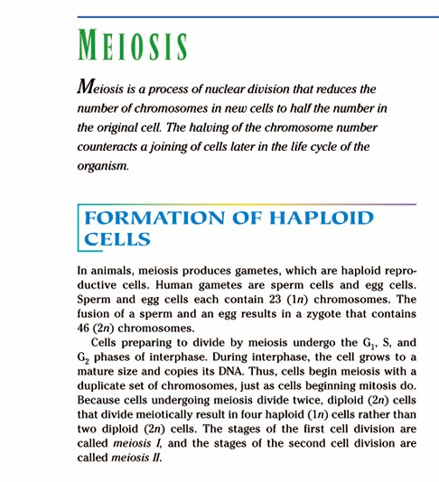
- How many divisions occur during meiosis?

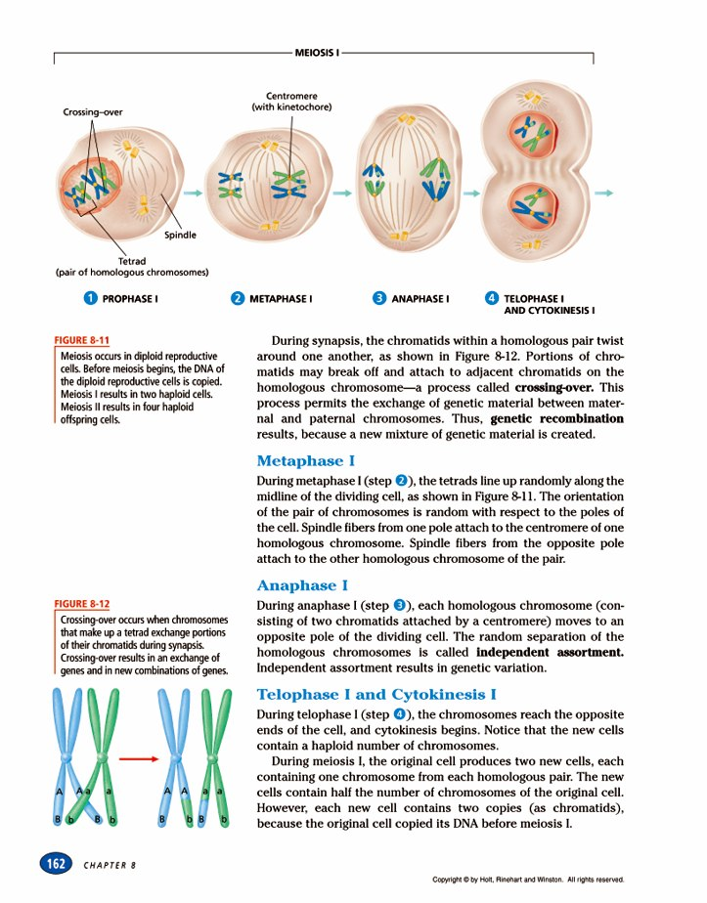
Station 2:
Read the paragraphs below and answer the questions

- Describe what occurs during prophase.
- Define synapsis.
- Define tetrad.
- Define crossing over
- Draw figure 8-12 (use different markers)
- What is genetic recombination?
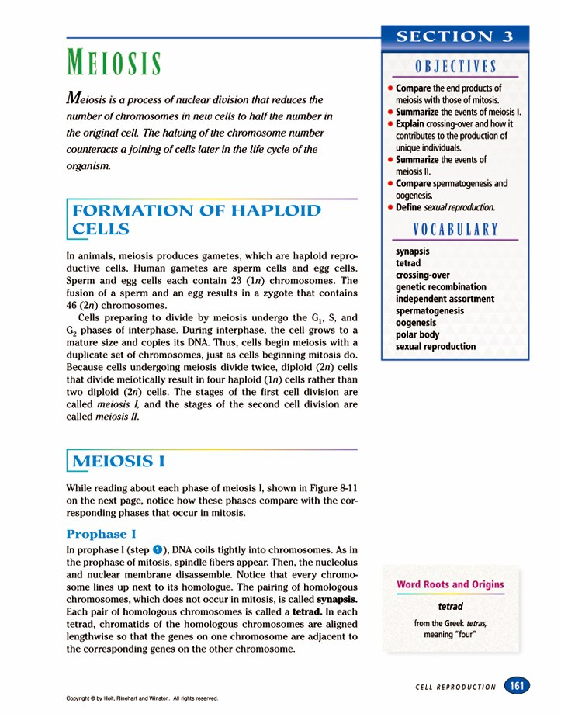

Station 3:
Read the paragraphs below and answer the questions

- Describe what occurs during metaphase I
- Describe what occurs during anaphase I
- Draw anaphase as shown below, use different colored markers – blue and green
- Now draw anaphase just like the first drawing but put all the blue on the top of the midline and the green on the bottom. Will this affect the genetic material of the gamete?
- What is independent assortment?

Station 4:
Read the paragraphs below and answer the questions

- Describe Telophase I and Cytokinesis I
- What is cytokinesis?
- How many cells are formed after Meiosis I?
- Are they haploid or diploid?
- Describe the new cells produced.

Station 5:
Read the paragraphs below and answer the questions

- Does DNA make a copy of itself before Meiosis II?
- Describe Prophase II, metaphase II, and anaphase II.
- Describe Telophase and Cytokinesis II.
- Compare meiosis II to mitosis?
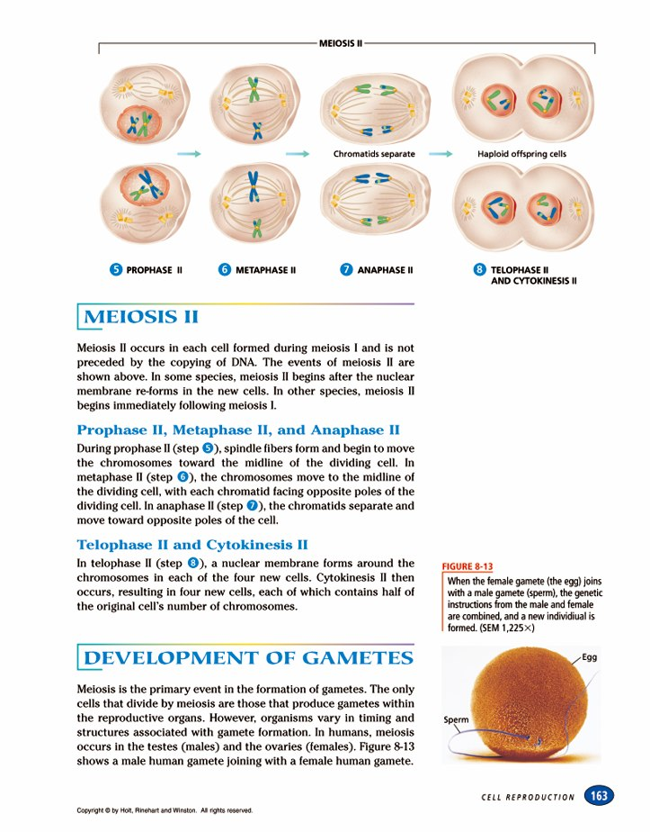
- How many total cells are produced after meiosis II?

Station 6:
Read the paragraphs below and answer the questions

- Where does meiosis occur in humans?
- Define spermatogenesis.
- Describe oogenesis.
- What occurs during the formation of egg cells? What are polar bodies?
- Draw fig.8-14 and label it
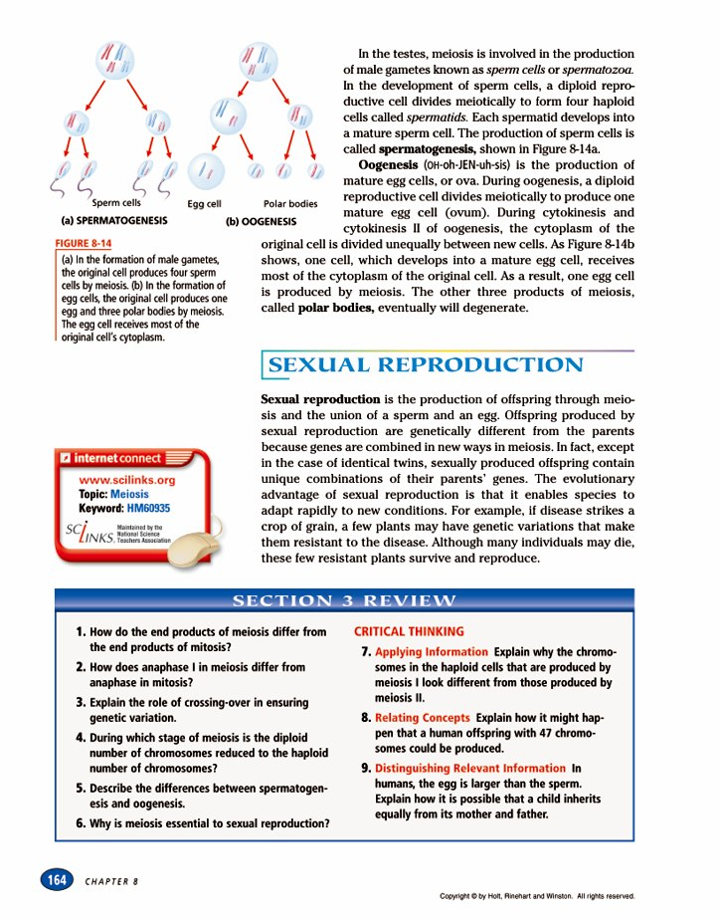

Station 7:
Read the paragraphs below and answer the questions.

- Define sexual Reproduction.
- Describe the offspring that are produced.
- What is the evolutionary advantage of sexual reproduction?

