**Cell Division (Ppg. 154)**

Approximately **2 TRILLION CELLS (2,000,000,000,000)** are produced by an adult human body EVERY DAY! That is equal to 25 MILLION CELLS (25,000,000) PER SECOND every day.

All cells come from the division of preexisting cells.

**CELL DIVISION** also known as **CELL REPRODUCTION** is the process by which cells produce offspring cells.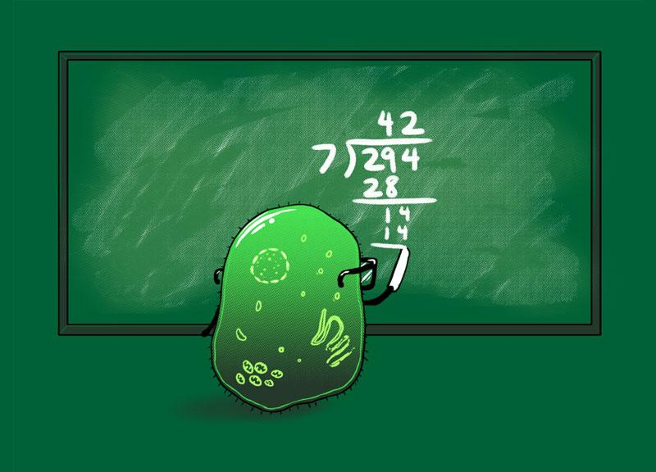

Cell division differs in Prokaryotes and Eukaryotes.

Cell Reproduction in Prokaryotes and Eukaryotes produce the same results which are the formation of two (2) cells from one (1).

* **Restate the question in your answer**
* **Answer in complete sentences**

1. **What is a cell? Explain.**
2. **Approximately how many cells are produced by an adult human body every day?**
3. **What do you think the difference between cell division and cell reproduction is?**

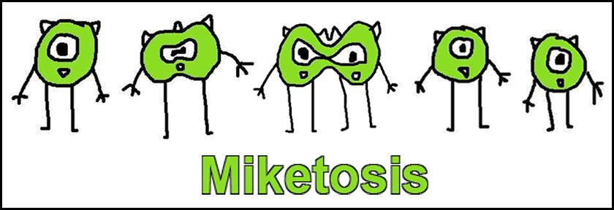

**Cell Division in Prokaryotes (pg. 154)**

Prokaryotes have cell walls but lack nuclei and membrane-bound organelles. A prokaryote’s single DNA molecule is not coiled around proteins to form chromosomes. Instead, a prokaryote’s DNA is a circular chromosome attached to the inner surface of a plasma membrane like a rope attached to the inner wall of a tent.

For most Prokaryotes, cell division takes place through a process called **BINARY FISSION**. Binary Fission is a form of **ASEXUAL REPRODUCTION**. Asexual reproduction is the production of offspring from one (1) parent.

Binary Fission is the division of a (1) prokaryotic cell into two (2) offspring cells.

Binary Fission: 1 → 2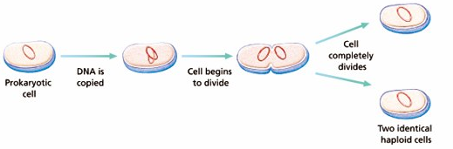

* The DNA is copied, resulting in TWO (2) IDENTICAL CHROMOSOMES attached to the inside of the prokaryote’s inner cell membrane.
* A new cell membrane then begins to develop between the two (2) DNA copies
* The cell grows until it doubles its original size and as new material is added, the growing cell membrane pushes inward and the cell is constricted in the center, like a balloon being squeeze in the middle.
* A new cell wall forms around the new membrane
* The dividing prokaryote is split into two (2) independent cells.
* Each cell contains one of the identical chromosomes that is resulted from the copying of the original cell’s chromosomes.

1. **Explain Binary Fission.**
2. **How could asexual reproduction be beneficial to an organism? How could it be detrimental to an organism?**
3. **What are the differences between Asexual reproduction & Human reproduction?**

**Cell Division in Eukaryotes (pg. 155)**

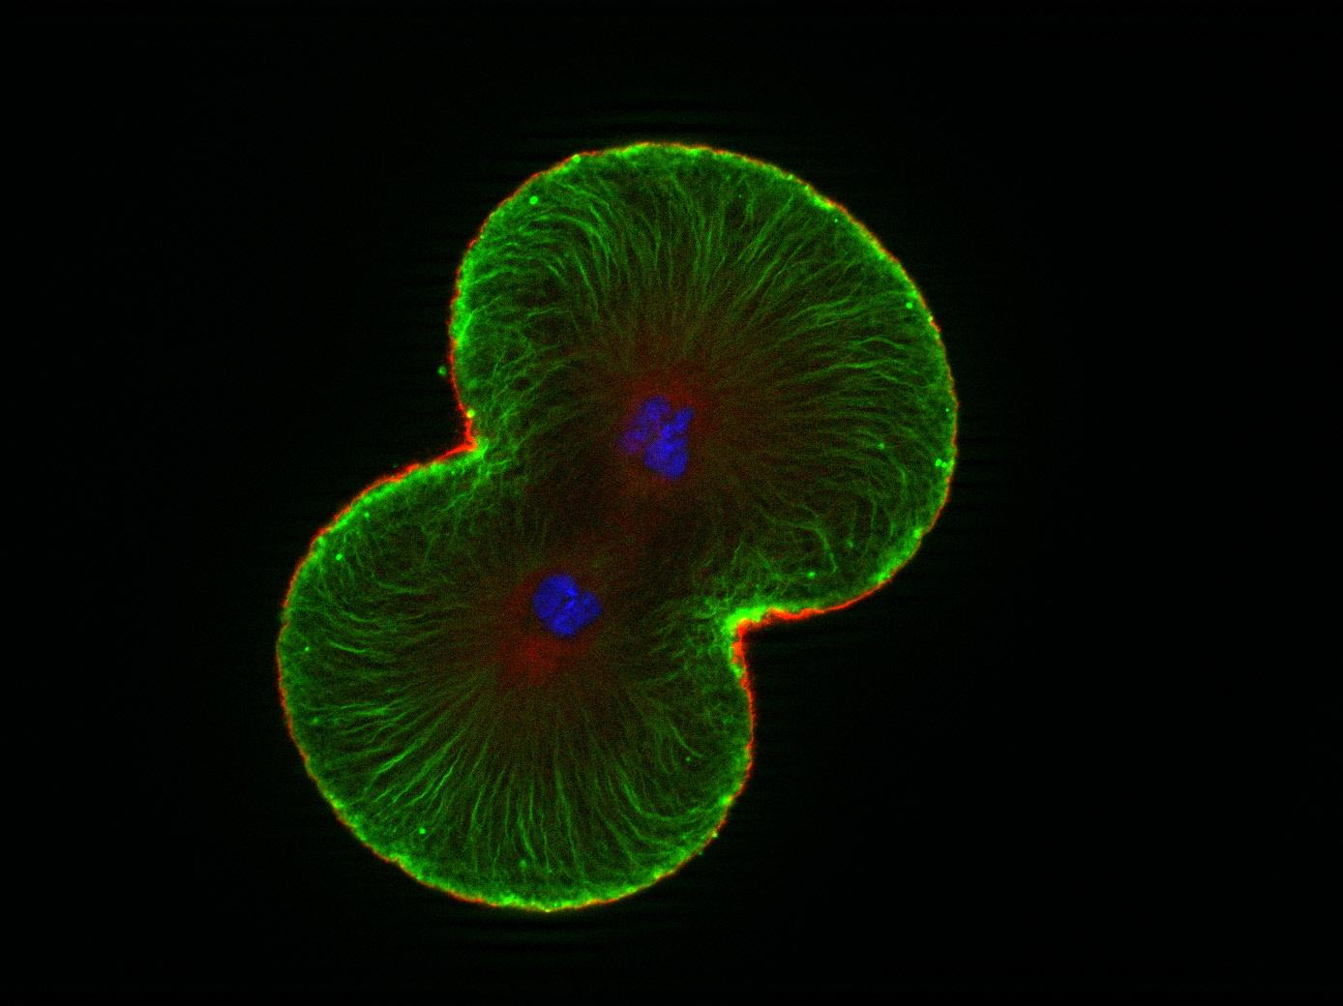

In Eukaryotic cell division, both the cytoplasm and the nucleus divide.

There are two kinds of cell division in Eukaryotes, **MITOSIS** & **MEIOSIS**.

**MITOSIS** results in new cells with genetic material that is identical to the genetic material of the original. MITOSIS results in an **EXACT COPY** of the cell being produced. Mitosis occurs in organisms undergoing growth, development, repair or asexual reproduction. Asexual reproduction is the production of offspring from one parent.

**MEIOSIS** occurs during the formation of GAMETES, which are haploid reproductive cells. Meiosis **reduces the chromosome number by half** in new cells. Each new cell has the potential to join with another haploid cell to produce a diploid cell with a complete set of chromosomes.

1. **What divides in Eukaryotic cell division? Why do you think this is important?**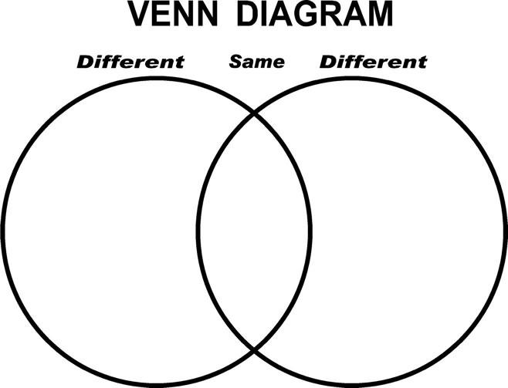
2. **Construct a Venn diagram and use it to compare and contrast Mitosis & Meiosis.**
   1. **How are they similar?**
   2. **How are they different?**
3. **How is Mitosis in Eukaryotic cells similar to Binary Fission in Prokaryotic cells?**

**The Cell Cycle**

The **CELL CYCLE** is the repeating set of events in the life of a cell. Cell division is one (1) phase of the cycle. The other phase of the Cell Cycle is **INTERPHASE**. Interphase is the time between cell divisions.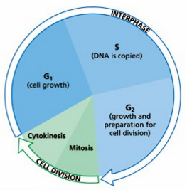

Interphase is divided into three (3) phases and cell division is divided into two (2) phases. During cell division, the chromosomes and cytoplasm are equally divided between two (2) offspring cells. CELL DIVISION CONSISTS OF MITOSIS & CYTOKINESIS. Mitosis is the division of the cell’s nucleus. CYTOKINESIS is the division of the cell’s cytoplasm. **Cells spend most of the cell cycle in interphase**. Following cell division, offspring cells are half the size of the original cell.

The **first stage of Interphase** – called the **G1 phase** – is when offspring cells grow to mature size.

The **second stage of Interphase** – called the **S phase** – is when the cell’s DNA (chromosome) is synthesized (copied).

The **third and final stage of Interphase** – called the **G2 phase** - is when the cell prepares for cell division.

Cells can also exit the cell cycle and enter a state called the **G0 phase**. During the G0 phase, cells do not copy their DNA and do not undergo for cell division. Fully developed Nerve cells in the Central Nervous System stop dividing at maturity and normally never divide again.

1. **What is the cell cycle? Explain.**
2. **Copy the Cell Cycle diagram into your composition notebooks.**
3. **Explain Interphase & all of its stages.**

**Stages of Mitosis**

Mitosis is the division of the nucleus, which occurs during cell division. Mitosis is a continuous process that allows for the organized distribution of a cell’s copied DNA to offspring cells. The process of mitosis is divided into four phases: Prophase, Metaphase, Anaphase & Telophase.

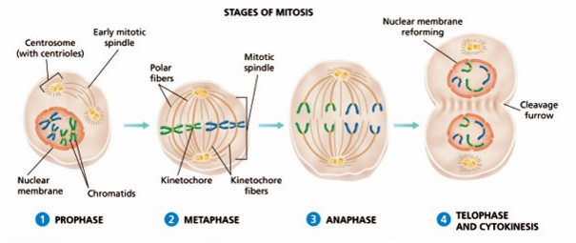

1. **Explain the process of Mitosis.**
2. **Draw the diagram above. Include all labels.**
3. **Explain why do you think Mitosis is important?**

**The 4 Stages of Mitosis: PROPHASE**

**PROPHASE** is the first phase of mitosis. Prophase begins with the shortening and tight coiling of DNA into ROD-SHAPED CHROMOSOMES that can be seen with a light microscope.

The two (2) copies of each chromosomes – the **CHROMATIDS** – stay connected to one another by the **CENTROMERE**. At this point, the **NUCLEOLUS** and the **NUCLEAR MEMBANE** break down and disappear.

Two pairs of dark spots called **CENTROSOMES** appear next to the disappearing nucleus. In **ANIMAL CELLS**, each centrosome contains a pair of small, cylindrical bodies called **CENTRIOLES**. The centrosomes of **PLANT CELLS LACK CENTRIOLES**.

As the centrosomes separate, **SPINDLE FIBERS** made of microtubules radiate from the centrosomes in preparation for metaphase. 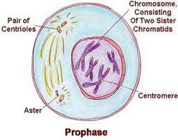

The array of spindle fibers is called the **MITOTIC SPINDLE**, which serves to equally divide the chromatids between the two offspring cells during division.

Two types of spindle fibers make up the mitotic spindle: kinetochore fibers and polar fibers.

1. **Thoroughly (in great detail) describe the prophase of Mitosis.**
2. **Explain the difference there is between the Prophases of Animal cells & Plant cells?**
3. **Why do you think the book references the use of a microscope when explaining the Prophase of Mitosis?**

**The 4 Stages of Mitosis: Metaphase & Anaphase**

**Metaphase** is the second phase of Mitosis. During metaphase, chromosomes are easier to identify using a microscope than during other phases; thus, karyotypes (**Karyotype** - the number and appearance of chromosomes in the nucleus of a eukaryotic cell) are typically made from photomicrographs of chromosomes in metaphase. 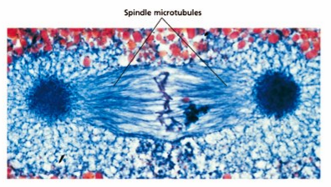

During **Anaphase**, the third step of Mitosis, the chromatids of each chromosomeseparate at the centromere and slowly move, centromere first, twoard opposite poles of the dividing cell. After the chromatids separate, they are considered to be individual chromosomes.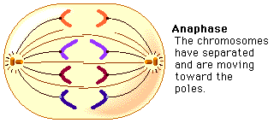

1. **Describe Metaphase**
2. **Describle Anaphase**
3. **Why would it be imporant during metaphase to identify Karotypes? Explain your answer**

**The 4 Stages of Mitosis: Telophase/Cytokinesis**

Telophase is the fourth and final step of Mitosis. After the chromosomes reach opposite end of the cell, the spindle fibers disassemble, and the chromosomes return to a less tighly coiled chromatin state. A nuclear envelope forms around each set of chromosomes and a nucleolus forms in each of the newly forming cells.

During Telophase, the cytoplasm begins dividing by the process of **CYTOKINESIS**. In animal cells, cytokinesis begins with a pinching inward of the cell membrane midway beween the dividing cell’s two poles.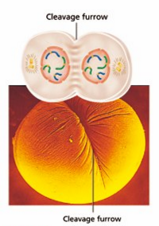

The area of the cell membrane that pinches in and eventually separates the dividing cell into two (2) cells is called the **CLEAVAGE FURROW**. The cleavage furrow pinches the cells into two (2) cells through the action of microfilaments.

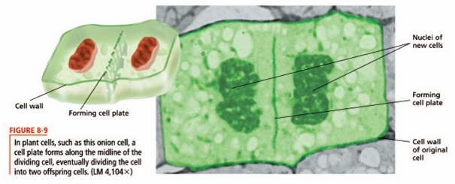

In Plant Cells, **VESICLES** from the Golgi apparatus join together at the midline of the dividing cell to form a **CELL PLATE**. A cell wall eventually forms form the cell plate at the midline, dividing the cell into two (2) cells.

In both animal and plant cells, offspring cells are approximately equal in size. Each offspring cell receives an identical copy of the original cell’s chromosomes and approximately one-half of the original cell’s cytoplasm and organelles.

1. **Describe Telophase/Cytokinesis in Animal cells**
2. **Describe Telophase/Cytokinesis in Plant Cells.**
3. **How is Telophase/Cytokinesis different in plant and animal cells? How is it similar? What causes these differences & why?**

**Control of Cell Division**

A cell spends most of its time in **interphase**, the time between cell divisions. **Proteins** regulate the progress of cell division at certain checkpoints. This system of protein checkpoints can be thought of as a kind of “traffic signal” for the cell. Control of the cell occurs at three (3) main checkpoints.

1. **Cell Growth (G1) Checkpoint**
   1. Proteins at this checkpoint control whether the cell will divide. If the cell is healthy and has grown to a suitable size during the G1 phase of interphase, proteins will initiate the S phase (DNA synthesis). The cell copies its DNA during this time. 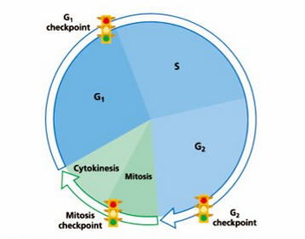
2. **DNA synthesis (G2) Checkpoint**
   1. During this time DNA repair enzymes check the results of DNA replication. If this checkpoint is passed, proteins will signal the cell to begin the process of division.
3. **Mitosis Checkpoint**
   1. If a cell passes this checkpoint, proteins signal the cell to exit mitosis. The cell then enters the G1 phase, the major growth phase of the cell cycle, once again.

**When Control is Lost: Cancer**

If a protein that regulates cell growth does not function properly, cell growth and division may be disrupted. This disruption could lead to cancer. Cancer is the uncontrolled growth of cells. Cancer cells do not respond normally to the body’s normal control mechanisms. Mutations cause cancers by increasing cell division or by interfering with the ability of control proteins to slow or stop the cell cycle.

1. **What type of Macromolecule regulates the cell cycle?**
2. **If you were to design your own cells, what would you change about them? Why?**
3. **With this information regarding the development of cancer, what would you do to combat this deadly disease? Why?**