Station 1
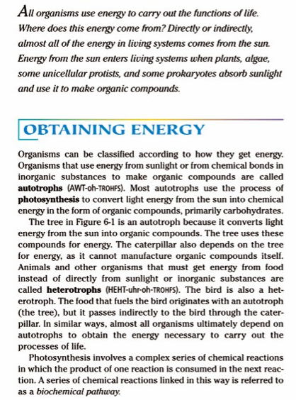

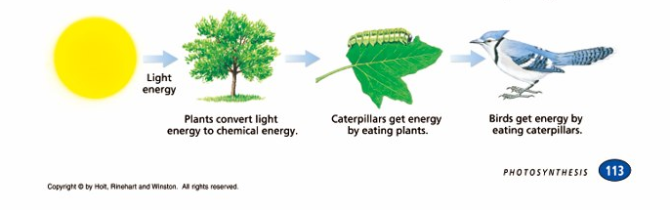

Station 2
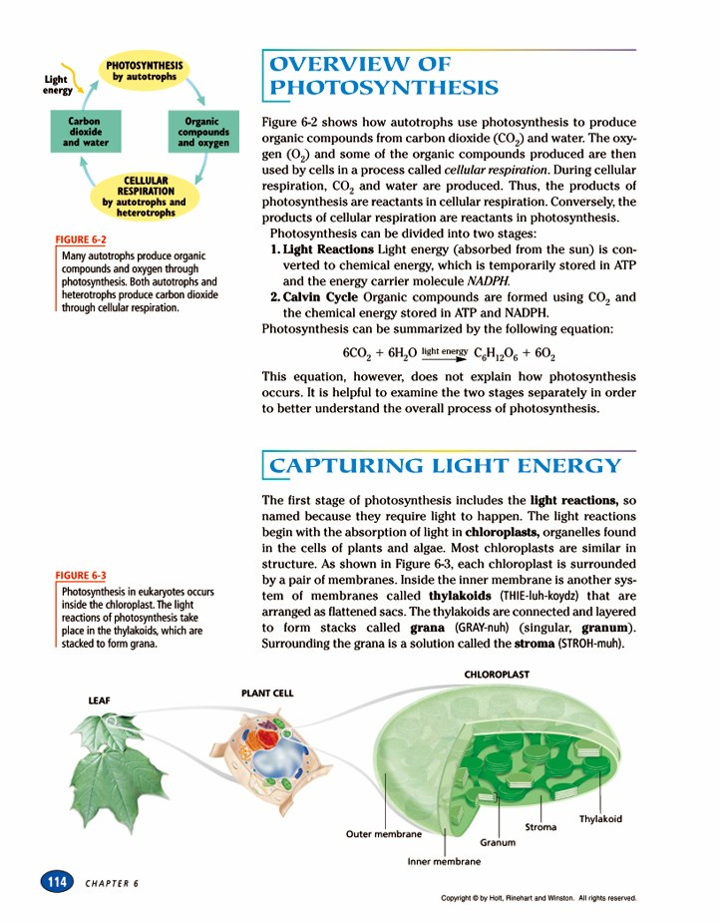

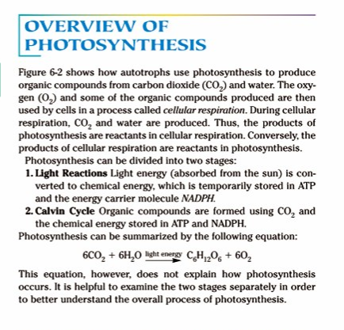

Station 3 Chlorplasts

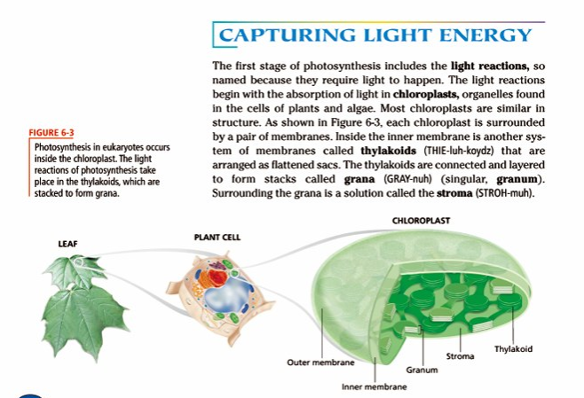

Station 4 Pigments
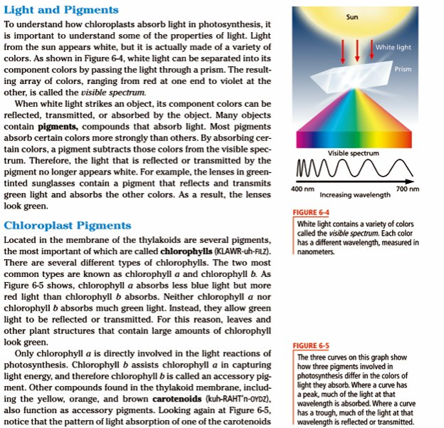
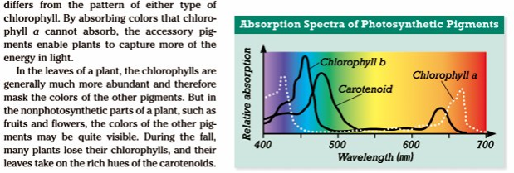

Station 5 Photosynthesis – Light Reactions

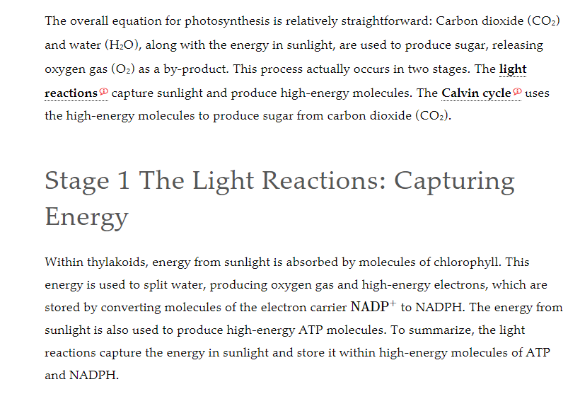
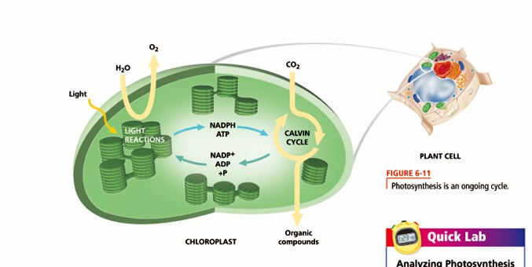

Station 6 – Calvin Cycle
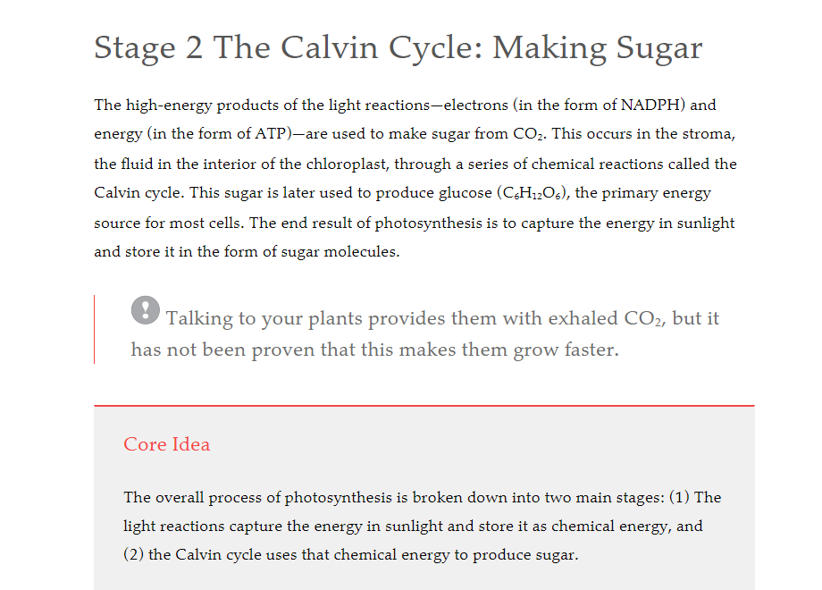

Station 7

Station 7

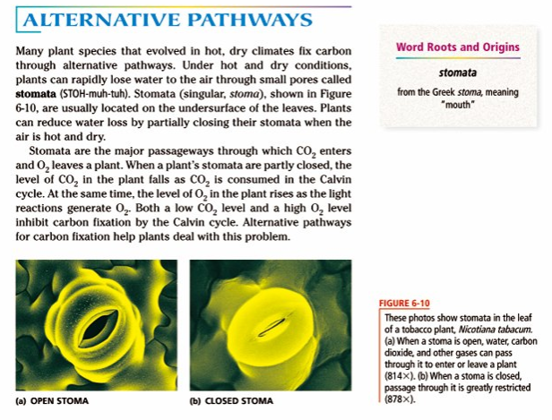

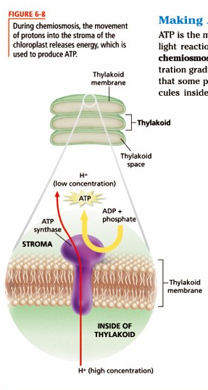

Station 8
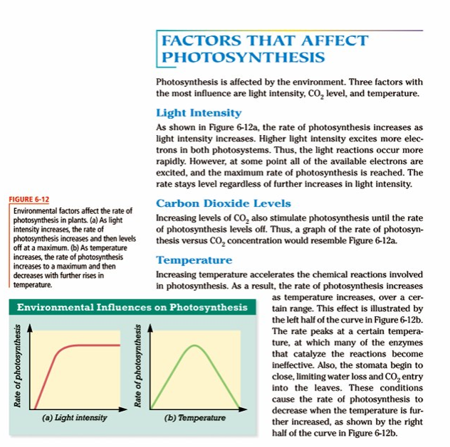

Name __________________________________________ Date _________ Hr. _____
Photosynthesis Information stations:
Station 1

- What energy do all organisms depend on for food – life?

- What is an autotroph?

- What type of organic compounds do most autotrophs make?

- What is a heterotroph?

- What is a biochemical pathway?

Station 2
- Explain how are photosynthesis and cellular respiration connected?

- List the two stages of photosynthesis

- What do the light reactions produce?

- What does the Calvin cycle produce?

- Write the equation for photosynthesis – identify each molecule.

Station 3
1. Where does photosynthesis take place?
2. Describe the following:
Thylakoids

Granum

Stroma

Station 4
- What is white light?

- Why do the leaves on a tree look green in the summer?

- What is chlorophyll and what does it absorb?

- What does a peak on the graph above indicate?

- Why do leaves change color in the fall?

Station 5
- Where do the light reactions take place?

- What do they produce?

- How is the energy used that is made in the light reactions?

Station 6
- What does the Calvin cycle produce?

- Where does the CO2 come from?

- Where does the Calvin cycle take place?

- What is the end result of photosynthesis?

Station 7
- What is a stoma?

- Where are they located?

- Why would they close?

- How would this affect photosynthesis?

Station 8
- List three factors that can affect the rate of photosynthesis.

- Describe what is happening in the graph on the left.

- Describe what is happening in the graph on the right.

