**Ecology Test Review**

1. What occurs when an Ecosystem is disrupted?
2. What is the ozone layer?
3. What is the function of the ozone layer?
4. What are CFC’s (chlorofluorocarbons)? How do they affect the ozone layer?
5. Draw a diagram, list at least three greenhouse gases and explain the heat trapping effect of the greenhouse effect? Why is it called the greenhouse effect?
6. Why do scientists believe the temperatures are increasing on Earth?
7. Define Ecology
8. Describe the interdependence of the organisms in an ecosystem.
9. What are producers? Give an example

***Use either of the diagrams above to answer the following questions.***





1. Label the producers, primary consumers, secondary consumers and tertiary consumers in the marine ecosystem.
2. Identify each herbivore by putting a capital H next to each organism in the terrestrial ecosystem.
3. Identify the carnivores by putting a capital C next to the organism in the marine ecosystem.
4. Identify each omnivore by putting a capital O next to the organism in the marine ecosystem.
5. What organism is at the highest trophic level in the terrestrial food web?
6. In a food web, which type of organism receives energy from every other type? Look at the terrestrial food web.

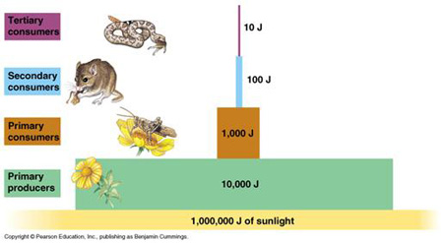

1. Refer to the illustration above. On the pyramid what organisms that feed on **plants eaters**?
2. Refer to the illustration above. How much energy is available to the primary consumers?
3. What is the 10% rule?

1. What limits the number of trophic levels in an energy pyramid?
2. What is a biogeochemical cycle?
3. What happens to the nitrogen in the body of an organism that dies?
4. How is atmospheric nitrogen converted into usable nitrogen for plants?
5. What type of nitrogen is formed from decaying organisms?
6. What is nitrogen fixation?
7. Plants use nitrates and nitrites to form what type of molecules?
8. What are fossil fuels?
9. How are fossil fuels formed?
10. What two greenhouse gases do they release when they are burned?
11. What is interspecific competition? (Look it up in your text or other resource).
12. What type of relationship occurs when two species attempt to use the very same resources?
13. What has been causing the accelerated rate of species extinction?
14. What is succession?
15. What type of succession is likely to occur after a forest fire?
16. When an abandoned farm is allowed to grow back into a forest what type of succession is this?

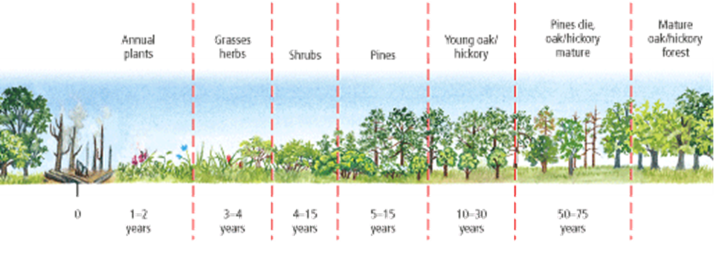

1. What type of succession is shown in the diagram above?
2. What type of plants are in the early stages of secondary succession?
3. What are biomes? (Give a good definition or explanation)
4. What type of biome has large evergreen trees that are adapted to long, cold winters?
5. Large herds of grazing animals are most likely to be found in what type of biome?
6. What type of animals would most likely live in a temperate deciduous forest like Michigan? (List at least three).