**Science Skills Station**

Objective

Predict how invasive species affect native species in an environment. Graph the change in native species and invasive species in an environment.

**Read:**

Overview

Ecosystems are disrupted when non-native species enter a new environment. They have no natural enemies in the new environment; out-compete native organisms for space, food and water; and rapidly overpopulate. These species are called invasive species.

Zebra mussels are an invasive species in the United States. They were first noticed in the Great Lakes in 1988. Scientists believe they were transported to the Great Lakes by ocean-going ships that traveled down the St. Lawrence River. It is believed the zebra mussels were carried on the bottom of these ships from their native habitat. They were originally native to the Black Sea, Caspian Sea and other waters in Southern Russia. Zebra mussels invaded the Mississippi, Hudson, Colorado, Tennessee and Arkansas Rivers from the Great Lakes. Now they are found in lakes, rivers and streams nationwide.

At this station, you will study how zebra mussels disrupt native populations of mussels in the Great Lakes. You will make inferences about how zebra mussels interact with the native mussels. You will also study how a new invasive species – the Quagga mussels – has furthered the problem(s) caused by zebra mussels.

**Science Skills Station cont**.

Activity #1

Below is a table with data on the population size of zebra mussels and native freshwater mussels in a United States body of water. The population of each species is recording over a 10 year period.

Directions: Create a double line graph that shows the change in population size of each species over the 10 year period. Create a scale for the x and y axis. Then plot the data for zebra mussels and native mussels. Be sure you graph includes:

* Labels for the x and y axis with units
* A key to differentiate between the two populations
* A consistent and regular interval on the x and y axis

|  |  |  |
| --- | --- | --- |
| Year | Population of Zebra Mussels (in millions) | Population of Native Mussels (in millions) |
| 1990 | 0 | 6.3 |
| 1992 | 6.5 | 2.3 |
| 1994 | 7.5 | 1.3 |
| 1996 | 7.0 | 1.3 |
| 1998 | 7.2 | 1.4 |
| 2000 | 7.0 | 1.4 |

Questions

1. Summarize the change in population size over the ten year period.
2. Is there a relationship between the change in population size of the zebra and native mussels? Explain.
3. Why did the population of zebra mussels increase rapidly during the first two years?
4. How else do you think Zebra mussels impact the ecosystem on this body of water?

**Science Skills Station cont**.

Activity #2

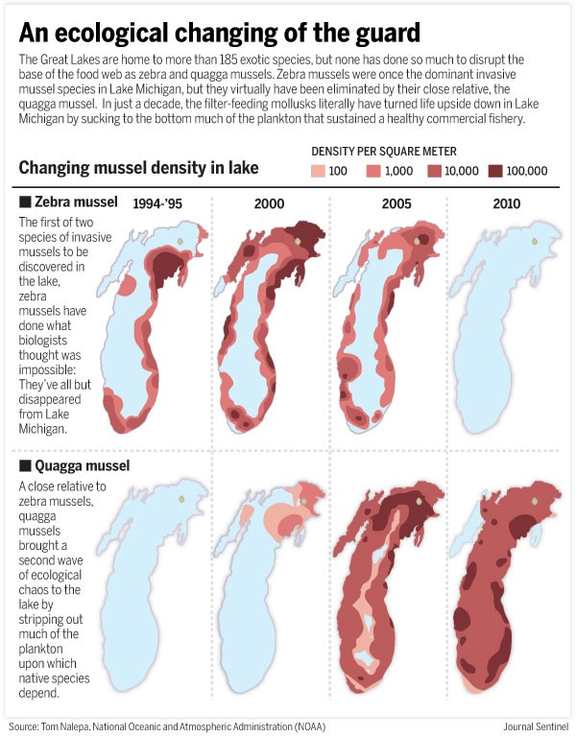Directions Below is an article excerpt, courtesy the NOAA regarding a new threat to the Great Lakes – the Quagga mussels. Read this excerpt. Then answer the questions.

Questions

1. What is the Quagga mussel? Why are scientists concerned about this species?
2. How has the population of the Zebra mussel changed over the past 15 years?
3. What has happened to the population of the Quagga mussel population over the past 15 years? Has this impacted the population of Zebra mussels? Explain.
4. Is it a good thing that the Quagga mussels impacted the presence of the zebra mussels? Justify your answer.
5. What do you think will happen to the Quagga mussels over the next ten years?

**Narrative Station**

Direction: Read the informational text. Then answer the following questions.

INVASIVE SPECIES

Ecosystems are disrupted when non-native species enter a new environment. They have

no natural enemies in the new environment; out-compete native organisms for space, food

and water; and rapidly overpopulate. These species are called invasive species.

Invasive species enter new environments intentionally and accidentally.

1. People have purposely introduced animals into an environment to help control pests. For example, cane toads were intentionally introduced to Florida and Hawaii to help control beetle populations. The beetles destroyed sugar cane crops. People thought introducing an organism that feeds on beetles was a safe way to eliminate the beetles that were destroying sugar cane. Unfortunately, the toads overpopulated and consumed resources needed by native species.

2. Most invasive species are accidentally introduced to new environments. Zebra mussels were accidentally introduced to the Great Lakes by ocean-going ships. They are now present in the Mississippi River, Hudson River and other lakes, rivers and streams nationwide. Zebra mussels compete with native clams and mussels. Fish feed on the zebra mussels which lead to overpopulation of fish. Zebra mussels also damage water intake pipes and other infrastructure such as docks.

Invasive species are a huge problem. Once an invasive species becomes a pest, it is very

difficult to remove it. Introducing a new organism to control the invasive species can just

exacerbate the problem. Many scientists do not want to use chemicals or pesticide to

kill the invasive species because they could harm native species. The best way to deal with

invasive species is to prevent them from invading new environments in the first place.

Activity #1 Questions:

1. What is an invasive species?

2. Why are invasive species a problem?

3. Why would someone intentionally introduce a species into a new environment?

4. What is the best way to deal with invasive species problems? Why?

**Narrative Station cont.**

Activity #2

Directions: Watch a 4 ½ minute video about releasing pets into the wild:

https://tinyurl.com/muoa432. Then answer the following questions.

Activity #2 Questions:

1. Why would be it a bad idea to release pet goldfish into a lake?
2. What kind of damage was caused when 100 starlings were released in New York?
3. What is exotic pet release?
4. How have red-eared slider turtles negatively impacted native turtle species in Europe?

Assessment Station

Objective

Recall concepts, terms and ideas relating to invasive species.

Skills Utilized

* Define key terms
* List steps to a process
* Explain a concept
* Determine relationship
* List pros & cons
* Interpret data

Assessment Direction

1. Answer the following questions. Write down your answers on the recording sheet.
2. There are two bonus questions. If time allows, try to answer these questions.

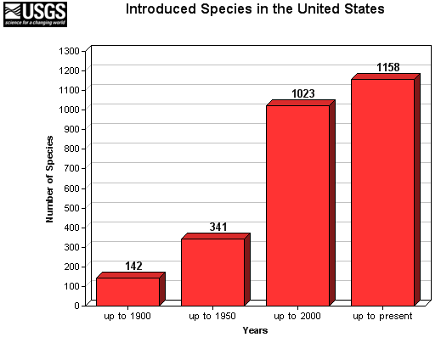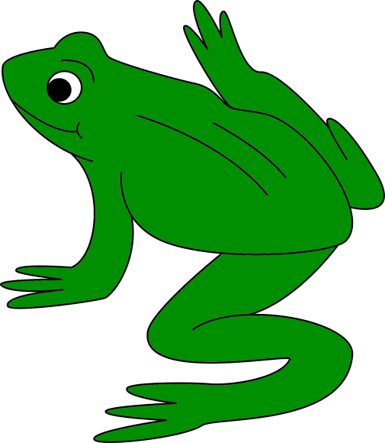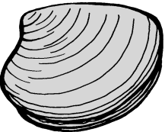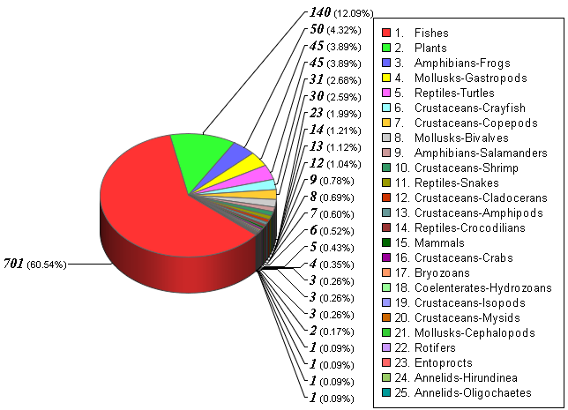

Question #1

What is an invasive species? Why is it able to thrive in a non-native habitat?

Question #2

How are native species impacted by the introduction of a non-native (invasive) species into an environment?

Question #3

The graph shows the number of species introduced in the United States up the last year listed (present = 2017). What does the graph tell us about invasive species in the United States?

Question #4

The graph shows the proportion of species introduced to the United States according to taxonomic group.

According to the graph, what is the most common invasive species in the US?

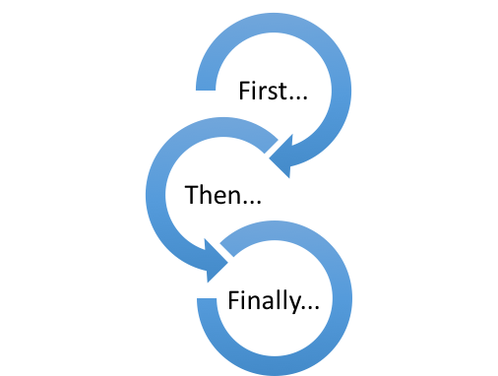

Question #5

Draw a diagram to show the the events that occur when an invasive species is introduced into a nonnative environment.

Question #6

A scientist wants to use a nonnative species of frogs to control an infestations of insects.

She believes this is a safer way to deal with the insect problems compared to pesticides.

Argue the pros and cons to this method. Identify the benefits and drawbacks to using nonnative species to control an insect problem.

BONUS Question #7

If you have ever traveled outside of the country, you or your parents may have filled out a customs declaration form. On the form you must declare food or animals you are transporting into the country.

Why do you think you are required to do this? Why is this important?

BONUS Question #8

How would someone solve an

invasive species problem? What whould he or she have to consider in removing the invasive species from an environment?

Problem Solving Station

Objective

Identify the problems associated with invasive species.

Evaluate solutions to remove invasive species from environments.

Skills Utilized

* Define problems
* Evaluate possible solutions

Overview

At this station, you will use a computer or tablet to study three invasive species. These are *real* cases of invasive species and the impact the invasive species have on environments are serious and consequential. You will study how the species were imported, the problems caused by the species and how scientists and government officials are trying to solve the problems.

Case #1: Cane Toads

1. Go to [http://www.invasivespeciesinitiative.com/cane-toad/.](http://www.invasivespeciesinitiative.com/cane-toad/)
2. Explain how (and why) cane toads were imported to Australia.
3. Identify problems caused by the cane toads. *How do they impact the environment?*
4. How are scientists trying to remove the cane toads and deal with the problems?
5. Evaluate the benefits, drawbacks and cost of the solution(s).

Case #2: Kudzu

1. Go to [http://www.invasivespeciesinitiative.com/kudzu/.](http://www.invasivespeciesinitiative.com/kudzu/)
2. Explain how (and why) kudzu was imported to the United States.
3. Identify problems caused by kudzu. *How does it impact the environment?*
4. How are scientists trying to remove kudzu and deal with the problems?
5. Evaluate the benefits, drawbacks and cost of the solution(s).

Case #3: Zebra Mussels

1. Go to [http://bit.ly/1B7jloC.](http://bit.ly/1B7jloC) *While navigating the site, be sure to click “Fact sheet about zebra mussels” to learn more about removing them from infested waters.*
2. Explain how zebra mussels were imported to the United States.
3. Identify problems caused by zebra mussels. *How do they impact the environment?*
4. How are scientists trying to remove zebra mussels and deal with the problems?
5. Evaluate the benefits, drawbacks and cost of the solution(s).