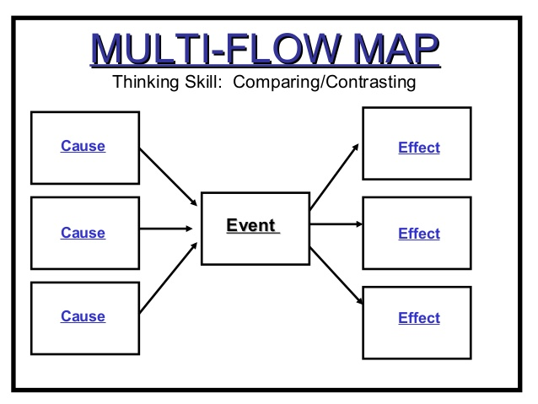***Directions: On your own paper make a table like this but with 5 cause boxes (choose 5) and 5 effect boxes. List the causes and effects in each box and write a sentence that explains each one.***

**What is Urban Sprawl?**

Urban sprawl is basically another word for urbanization.  It refers to the migration of a population from populated towns and cities to low density residential development over more and more rural land.  The end result is the spreading of a city and its suburbs over more and more rural land. In other words, urban sprawl is defined as low density residential and commercial development on undeveloped land. Most of the time, people will move from these areas to try to find better areas to live. This has been the way of the world since the beginning.

Migration and urban sprawl isn’t something that is just now becoming popular, as it has been around for quite some time.  Cities and their suburbs are now becoming overcrowded because of this, but now it is time to look at the causes and the effects of the urban sprawl, so that you can gain a better understanding of it.

[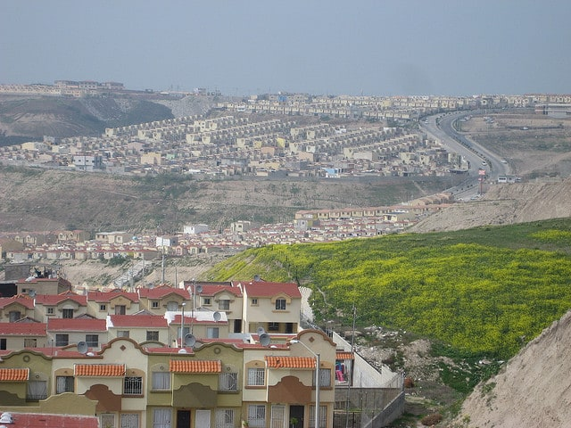](https://www.conserve-energy-future.com/wp-content/uploads/2013/12/Urban_Sprawl.jpg)Causes of Urban Sprawl

Urban sprawl can be caused by a variety of different things.  These causes will mainly include:

* **Lower Land Rates:** Lower cost land and houses in the outer suburbs of the cities, because the centers of urban development have really made people want to stop settling in these areas and want to venture further out.
* **Improved Infrastructure:** There is increased spending on certain types of infrastructures, including roads and electricity.  This is something that hasn’t always been available, and there are still some areas that don’t have these luxuries.  That doesn’t mean that they aren’t working on it.
* **Rise in Standard of Living:** There are also increases in standards of living and average family incomes, which means that people have the ability to pay more to travel and commute longer distances to work and back home.
* **Lack of Urban Planning:** People love to find areas that are less trafficked and calmer, which leads them to sprawl out to other sections of the town. Unprecedented development, cutting of trees, loss of green cover, long traffic jams, poor infrastructure force people to move out to new areas.
* **Lower House Tax Rates:** Cities will usually have high property taxes, and you can usually avoid these taxes by living in the outer suburbs because the taxes are usually lower than they would be in other situations.
* **Rise in Population Growth:**Another factor that contributes towards urban sprawl is [rise in population](https://www.conserve-energy-future.com/causes-effects-solutions-of-overpopulation.php) growth. As number of people in a city grows beyond capacity, the local communities continue to spread farther and farther from city centers.
* **Consumer Preferences:**People in high income groups have stronger preferences towards larger homes, more bedrooms, bigger balconies and bigger lawns. This also causes urban sprawl as this option is not available in crowded cities. People generally look out for low-density residential areas where they can get home according to their preference.

[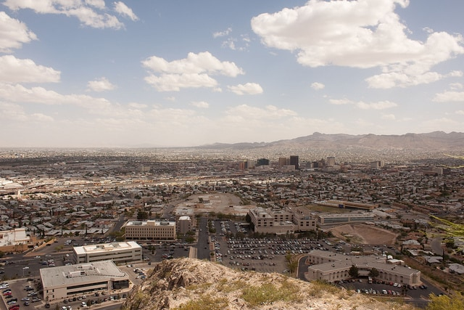](https://www.conserve-energy-future.com/wp-content/uploads/2013/12/Causes_of_Urban_Sprawl.jpg)Effects of Urban Sprawl

Now, we will take a look at the effects of urban sprawl, now that we have taken a closer look at the causes of it.  Some of the effects include:

* **Increase in Public Expenditure:** They can actually play a part in the increases of public costs, because these changes in infrastructures and building must actually be paid for by someone- and it is usually the tax payers money that pays for it.
* **Increased Traffic:** Populations will begin to use their cars more often, which means that there is more traffic on the roads, and there is also more [air pollution](https://www.conserve-energy-future.com/various-air-pollution-facts.php) and more auto accidents that you have to worry with.
* **Health Issues:** When people use their vehicles, even to go to a very short distance, people are going to be more overweight and are also going to have to deal with ailments such as high blood pressure and other diseases that come about with obesity.
* **Environmental Issues:** Sprawls can also cause certain [environmental issues](https://www.conserve-energy-future.com/current-environmental-issues.php) that you may want to be aware of.  In fact, when you think about going out to develop these lands you will have to worry about the wildlife that lives in these lands.  You will be displacing them, and it can really cause a ripple in the environment.
* **Impact on Social Lives:** When people move further out, they also have an impact on their social lives.  They don’t have neighbors that live as close, which means that they won’t really stay as social as they should.  This isn’t always the case, but it is something that should be taken note of.

As you can see, urban sprawl is something that will continue to occur as long as we live here on earth.  It isn’t something that is going to change, but over time the more rural areas are going to become more populated because of development and change.  This can be considered a good thing at times, but others view it as a bad thing.  You also have to consider the fact that it will actually play a part in having to cut down more trees and tear up the environment, and in this aspect, it is not a good thing.

On a positive note, it may lead to less overcrowding- but it won’t happen overnight.  Its clear that urban sprawl is something that people will consider to be a good thing or a bad thing, depending on their own beliefs systems.  You may find it to be something that is ideal, while others may want to steer clear of it.  It is the inevitable, that’s for sure, but that doesn’t mean that it has to be rushed into, and it should happen naturally.